SUBCOURSE EDITION
AD 0448 A

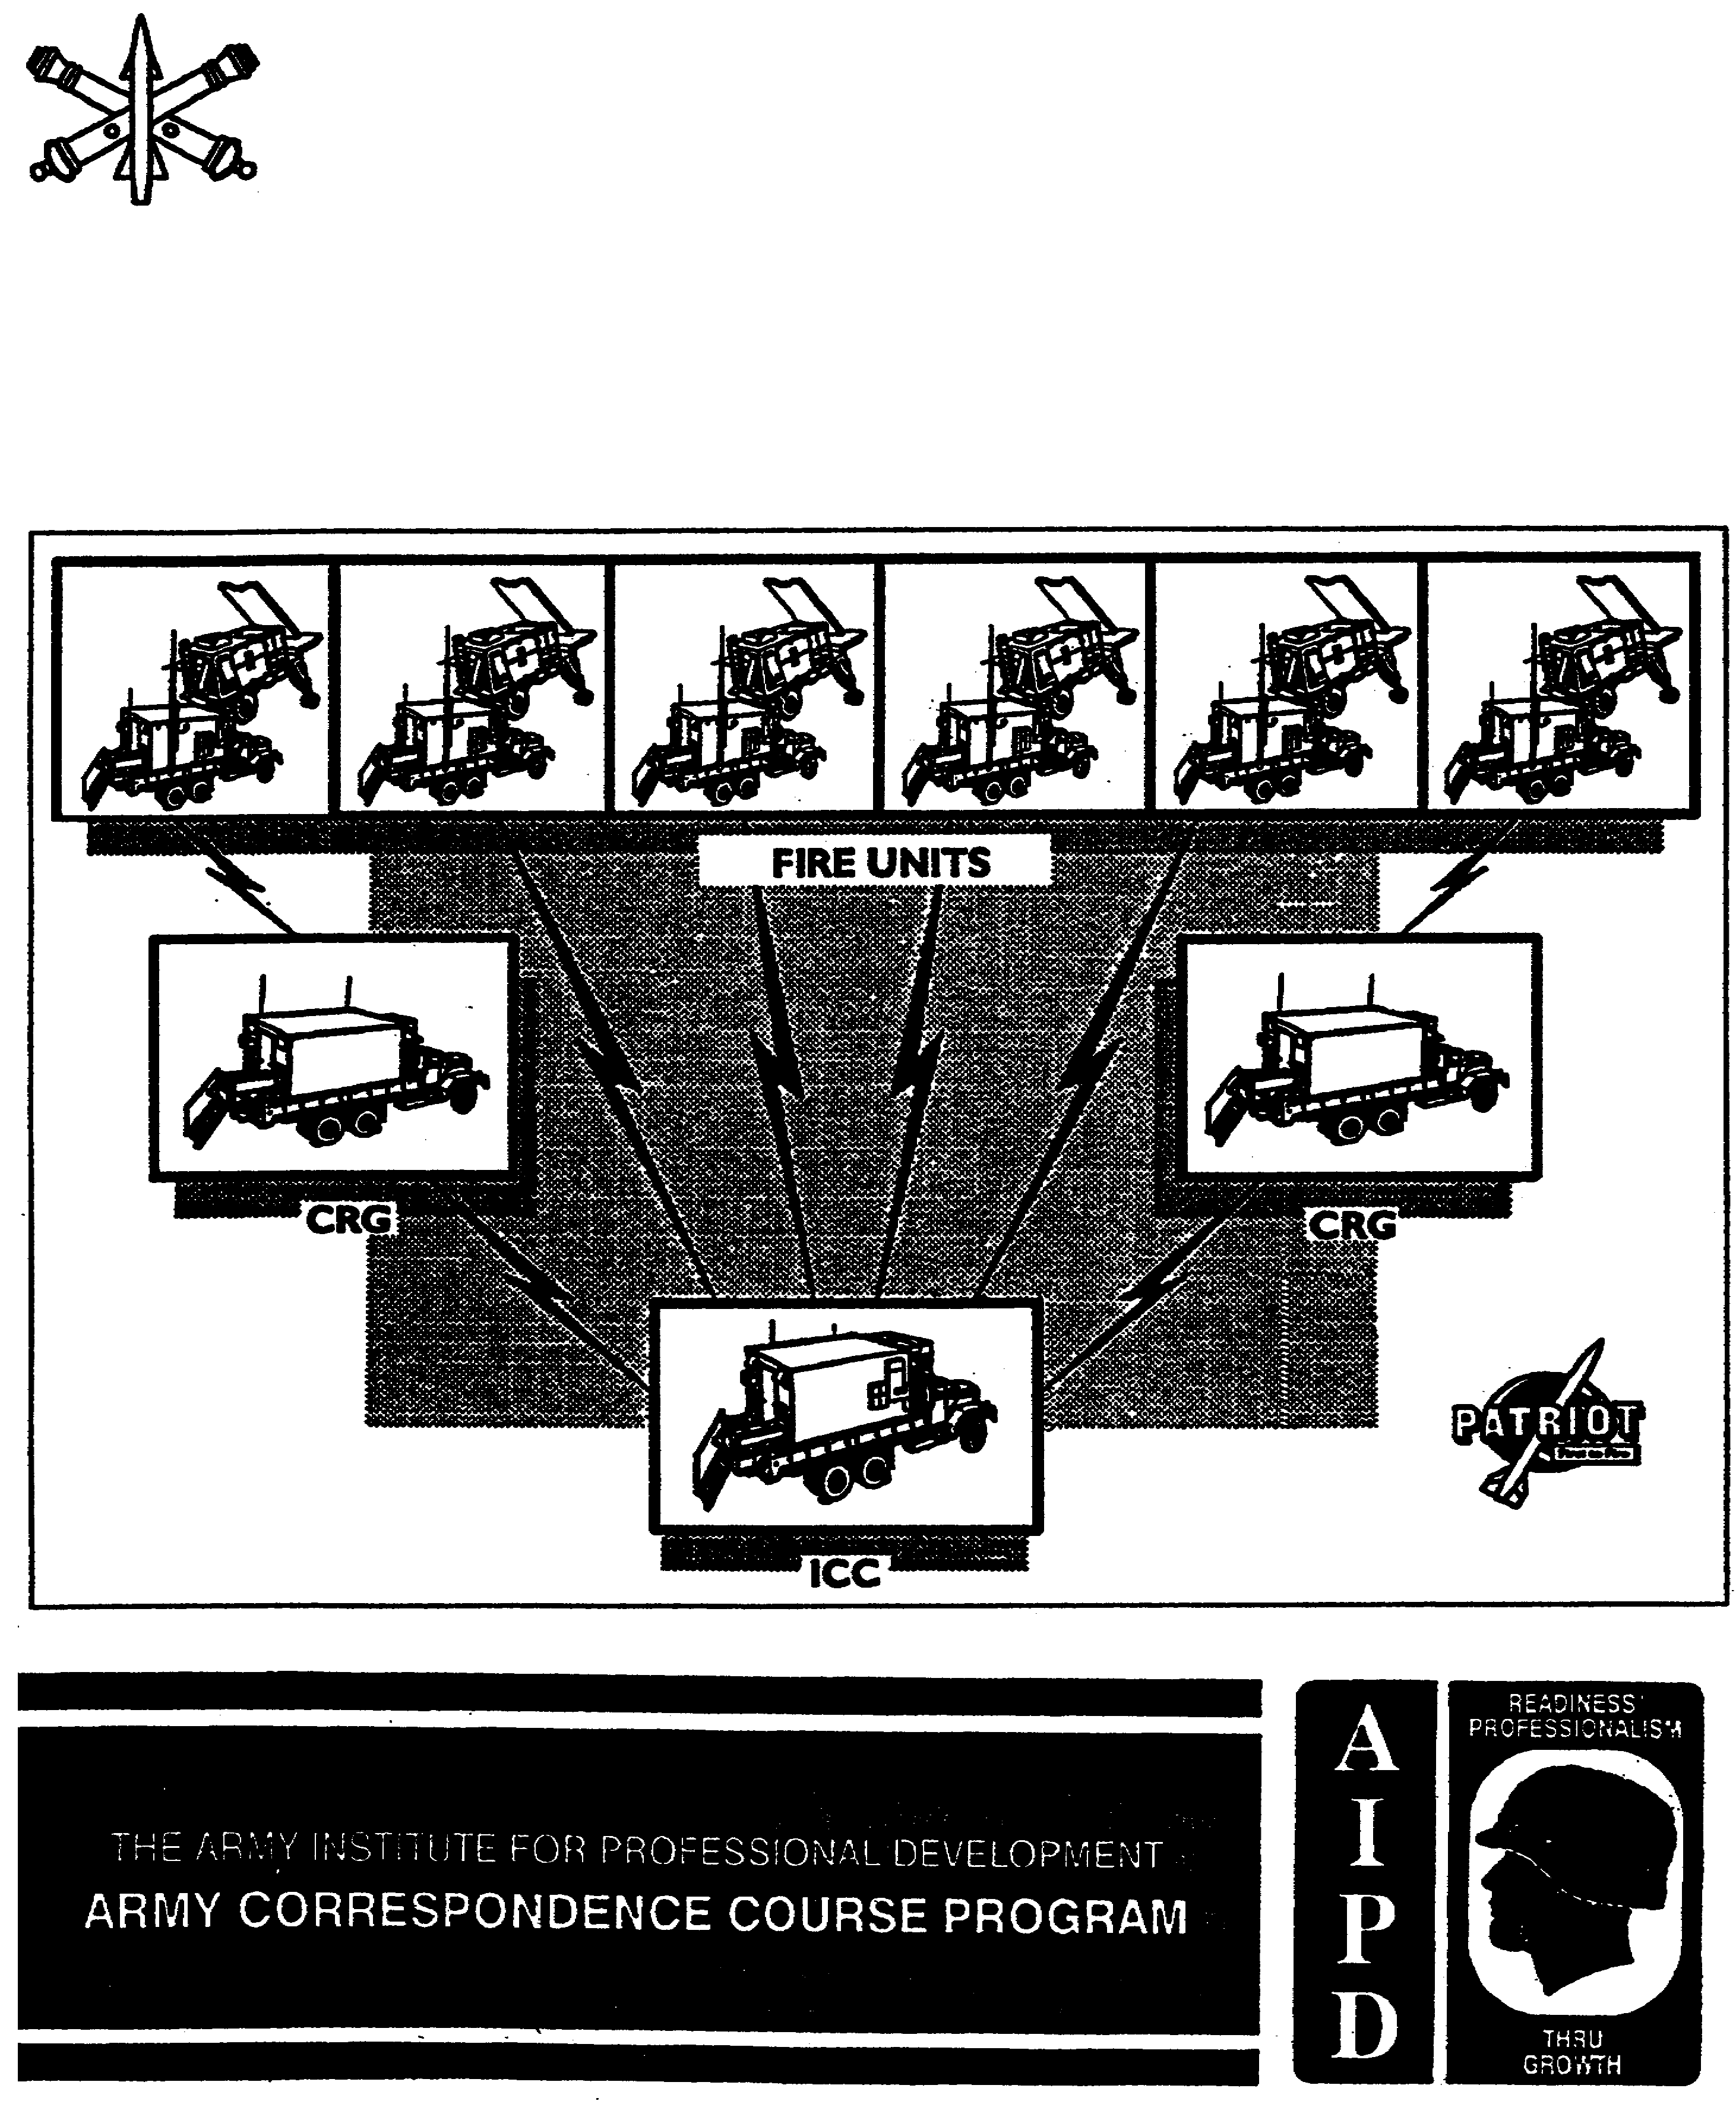
US ARMY
AIR DEFENSE ARTILLERY SCHOOL

PATRIOT SYSTEMS COMMUNICATIONS

PATRIOT SYSTEMS COMMUNICATIONS

SUBCOURSE NUMBER AD 0448

EDITION A

United States Army Air Defense Artillery School
Fort Bliss, Texas 79916-3802

8 Credit Hours
Edition Date: October 1994

SUBCOURSE OVERVIEW

This subcourse is designed to teach you the basic communications equipment used in a Patriot unit.

The prerequisite for this subcourse is AD 0415, Introduction to the Patriot System.

This subcourse reflects the doctrine which was current at the time it was prepared. In your own work situation, always refer to the latest official publications.

Unless otherwise stated, the masculine gender of a singular pronoun is used to refer to both men and women.

TERMINAL LEARNING OBJECTIVE

ACTION: You will identify and describe the type of communications and communications equipment used in a Patriot battalion or battery.

CONDITION: You will be given textual information and illustrations directly related to the subjects as listed in the action statement.

STANDARD: To demonstrate competency in the communications procedures, as instructed in this subcourse, you must achieve at least a minimum of 70% on the subcourse examination.

i AD 0448

REFERENCES: The material contained in this lesson was derived from the following publications: FM 24-19, STP 44-16T1-SM, STP 44-24T1-SM, TM 11-5805-201-12, TM 11-5820-401-10-1, TM 11-5820-401-10-2, TM 11-5820-477-12, TM 11-5820-498-12, TM 11-5820-667-12.

AD 0448 ii

TABLE OF CONTENTS

Section Page

Subcourse Overview i

Lesson 1: Radio Sets AN/PRC-77 and AN/GRC-160 1-1

PART A: Operation of the Radio Set AN/PRC-77 1-2

PART B: Operation of the Radio Set AN/GRC-160 1-12

Practice Exercise. 1-17

Answer Key and Feedback 1-21

Lesson 2: Radio Sets AN/VRC-46 and AN/VRC-47 2-1

PART A: Operation of the Radio Set AN/VRC-46 2-2

PART B: Operation of the Radio Set AN/VRC-47 2-8

PART C: Operation of the Radio Set Control Group
AN/GRA-39 2-14

Practice Exercise 2-20

Answer Key and Feedback 2-23

Lesson 3: FM Radio Nets 3-1

Practice Exercise 3-6

Answer Key and Feedback 3-9

Lesson 4: Installation of a Hot Loop 4-1

Practice Exercise 4-5

Answer Key and Feedback 4-9

iii AD 0448

APPENDIX A LIST OF COMMON ACRONYMS AND ABBREVIATIONS A-1

APPENDIX B REFERENCES B-1

AD 0448 iv

LESSON 1

RADIO SETS AN/PRC-77 AND AN/GRC-160

CRITICAL TASKS: 113-587-1063
113-587-2001
113-587-2002
113-587-3001

OVERVIEW

LESSON DESCRIPTION

In this lesson you will learn how to operate the AN/PRC-77 in the man-pack configuration and in the vehicle configuration (AN/GRC-160).

ENABLING LEARNING OBJECTIVES:

ACTION: You will identify and describe the components, operation, and preventive maintenance checks and services (PMCS) of the AN/PRC-77 and AN/GRC-160.

CONDITION: You will be given textual information and illustrations within the AD 0448 subcourse booklet.

STANDARD: To demonstrate competency of the instructions contained in this lesson, you must achieve a minimum score of 70% on the subcourse examination.

REFERENCES: The material contained in this lesson was derived from the following publications: STP 44-16T1-SM, STP 44-24T1-SM, TM 11-5820-498-12, and TM 11-5820-667-12.

INTRODUCTION

In Patriot units the need to effectively use radio communications is extensive. The primary radio used by the launcher crews is an AN/PRC-77. When this radio is installed in a truck, its name changes to AN/GRC-160. You will find that you must use your radio in the engagement control station (ECS) to communicate with the launchers and the launchers have to communicate with the ECS.

1-1 AD 0448

PART A: OPERATION OF THE RADIO SET AN/PRC-77

LEARNING EVENT 1: Describe Placing the Radio Set AN/PRC-77 into Operation

1. GENERAL. This learning event will provide you with instructions on preparing the AN/PRC-77 for operation.

2. DESCRIPTION. The radio set AN/PRC-77 has a receiver/transmitter (RT), RT-841, (Figure 1-1, item 1) which is the heart of the radio. The AN/PRC-77 has several minor components which, together with the RT-841, make up an operational radio set AN/PRC-77.

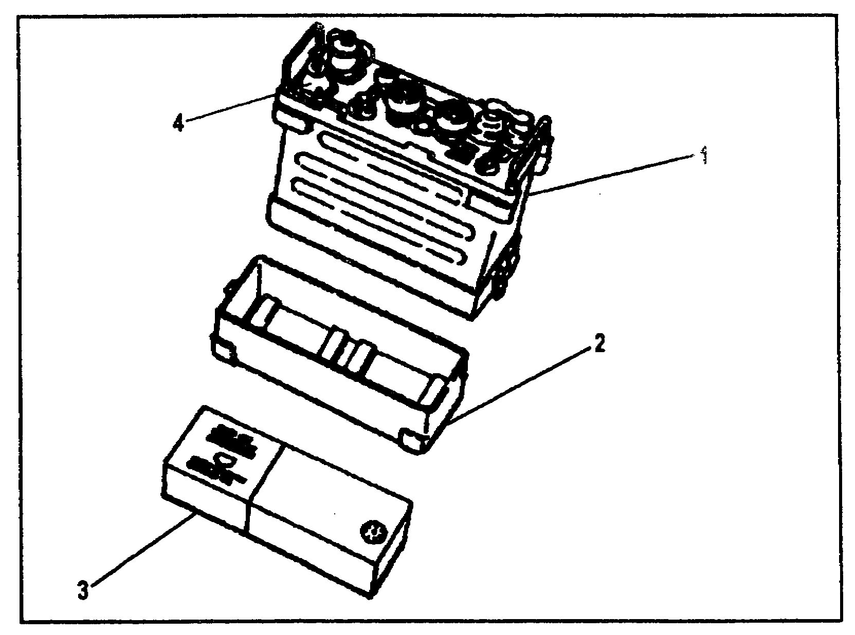

Figure 1-1. Receiver/transmitter, RT-841

a. The RT-841 consists of the receiver/transmitter (item 1), the case, and a battery box, CY-2562 (item 2). The complete RT-841 is watertight; when it is assembled.

(1) The receiver/transmitter is held in the RT-841 case by four captive screws.

(2) The battery box is a light weight metal case that protects and houses the battery (item 3). It is attached to the case by two clamps. The battery sits on foam pads attached to the bottom of the box.

AD 0448 1-2

b. The AN/PRC-77 has six minor components (Figure 1-2).

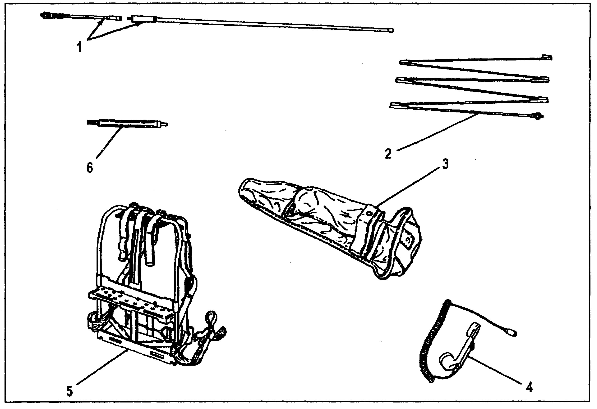

Figure 1-2. Radio set AN/PRC-77 minor components

(1) The antenna, AT-892, (item 1) is a one-section, three foot long whip antenna. A spring at the base of the AT-892 keeps the antenna in a vertical position. This antenna is used for general short-range service.

(2) The antenna, AT-271A, (item 2) is composed of six sections; each section fits into the end of a wider section. A stainless steel, plastic-covered cable, under-spring tension is threaded through the sections to hold them together. When the sections are folded, the cable keeps them together as a group and prevents the loss of individual sections. Spring tension is provided by a spiral spring in the base section. This antenna is used when maximum range is required.

1-3 AD 0448

(3) The equipment bag, CW-503, (item 3) is divided into several pockets which are used to store the two antennas, the antenna support, and the handset.

(4) Either of the following handsets (item 4) may be used with the AN/PRC-77.

(a) The handset, H-189/GR, contains a dynamic microphone and receiver for transmitting and receiving signals. A push-to-talk switch is mounted in the handle. The connecting cord is retractable and is terminated with a five-pin connector.

(b) The handset, H-250/V, is similar to the H-189/GR except it is lighter and more rugged.

(5) The harness, LC-2, (item 5) is used to secure the RT-841 so it can be carried on the operator's back.

(6) The antenna base, AB-591A, (item 6) is used as a main support for the AT-271A. It has a rigid tubular construction.

3. PREPARE TO OPERATE.

a. The AN/PRC-77 operates at low power and on high frequencies; therefore, the location of the equipment greatly affects its operating range (distance). Normally, a line-of-sight range can be expected; that is, if the other station can be seen, satisfactory operation is likely. An intervening hill or a tall building may hamper or prevent contact with other stations. Valleys, densely wooded areas, and low places are poor sites. Location on a hill top or a tower will increase the operating range. If tactically possible, avoid locations near sources of electrical interference, such as power or telephone lines, radar sets, or a field hospital.

AD 0448 1-4

b. To install the radio battery (Figure 1-3, item 4), perform the following:

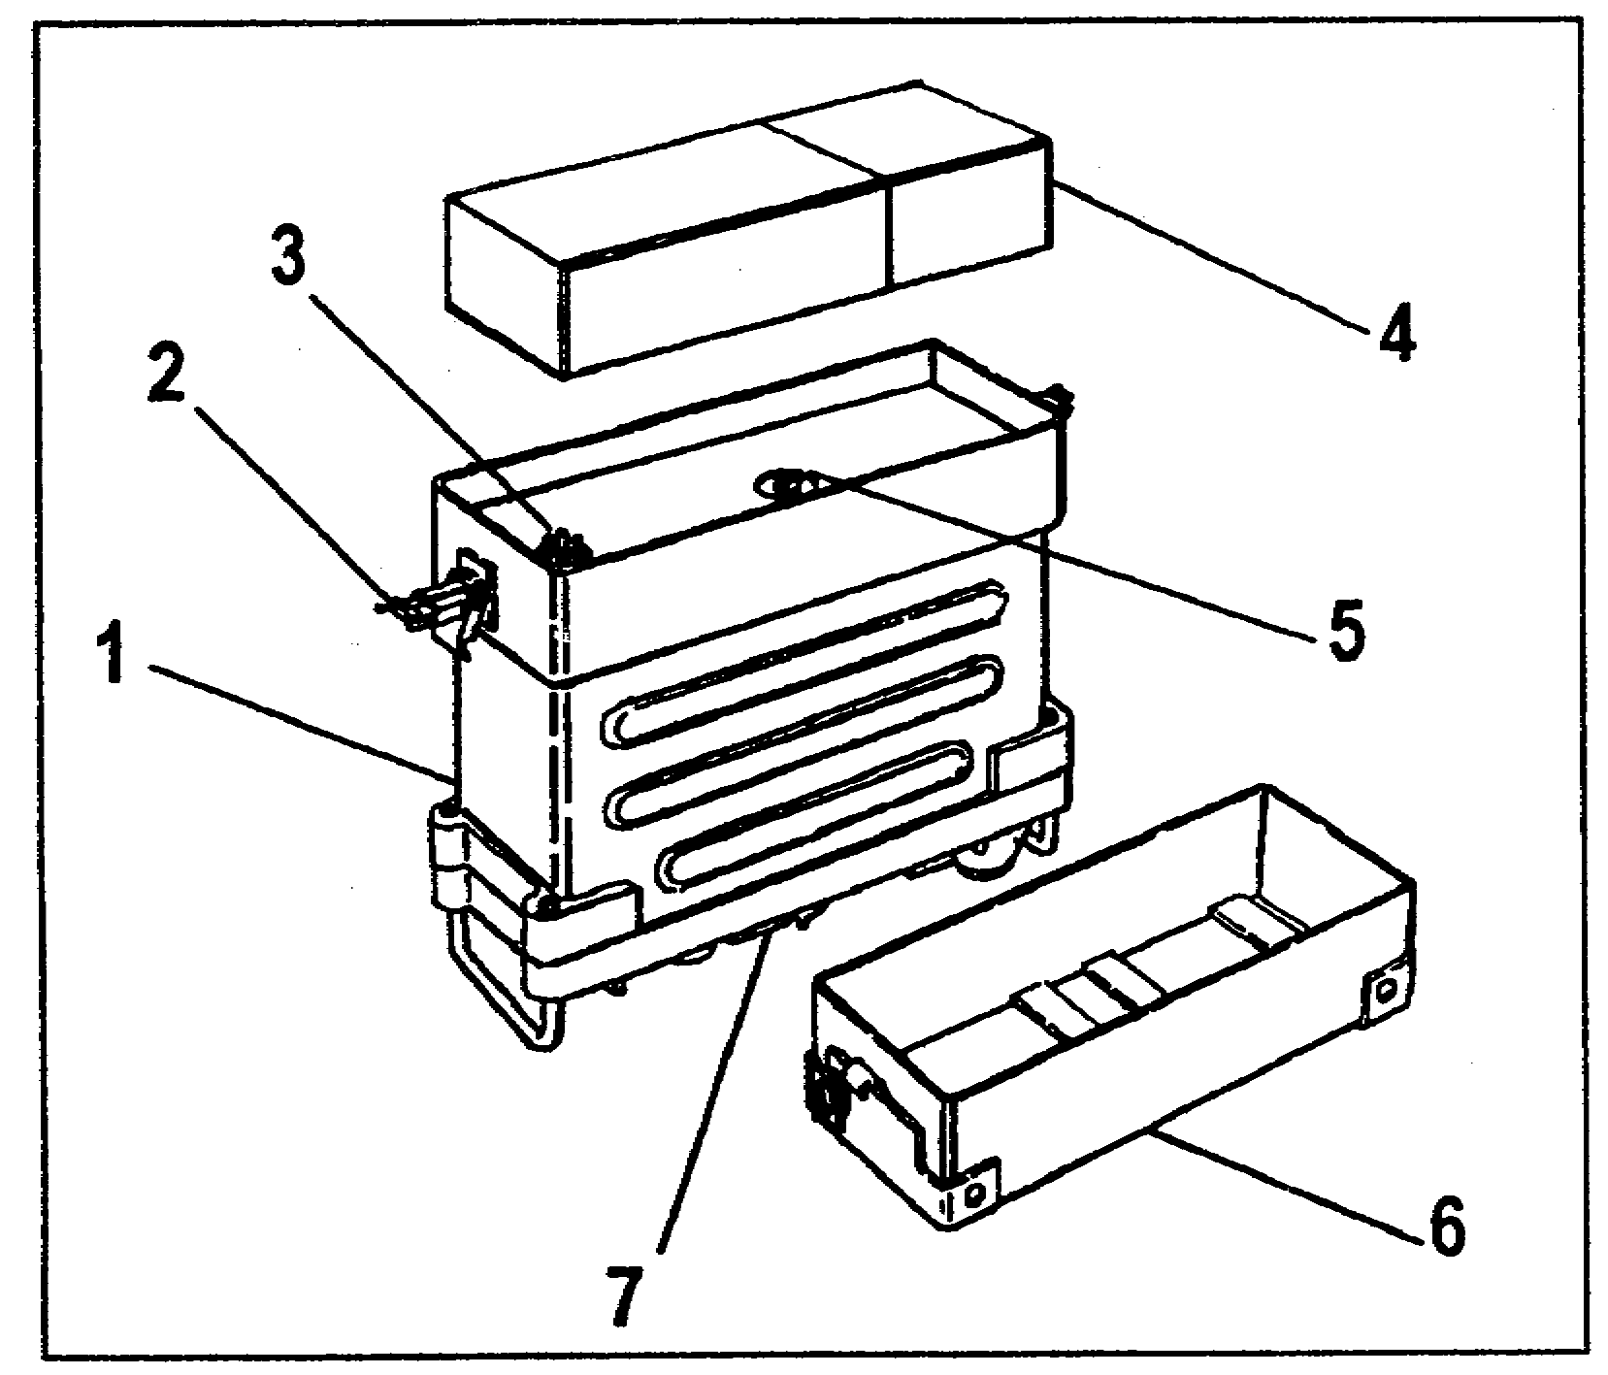

Figure 1-3. Battery installation

(1) Place the RT-841 (item 1) on a level surface with the front panel (item 7) facing down.

(2) Release the two clamps (item 2) by pushing the top most piece of each clamp down and away from the RT case.

(3) Remove the battery box, CY-2562, (item 6) and separate the battery (item 4) from the electrical radio connector (item 3).

(4) Inspect the radio connector. If it is damaged or loose, the RT-841 must be repaired. Tighten the pressure test screw (item 5) if it is loose.

(5) Position the new battery (item 4) on the radio connector so the two are mated together.

(6) Reinstall the battery box, CY-2562, (item 6) into the RT-841 metal case (item 1) and tighten the two clamps (item 2).

1-5 AD 0448

c. The AN/PRC-77 can be carried on a soldier's back on a LC-2 frame (Figure 1-4, item 1). To assemble and install it for man-pack use, perform the following:

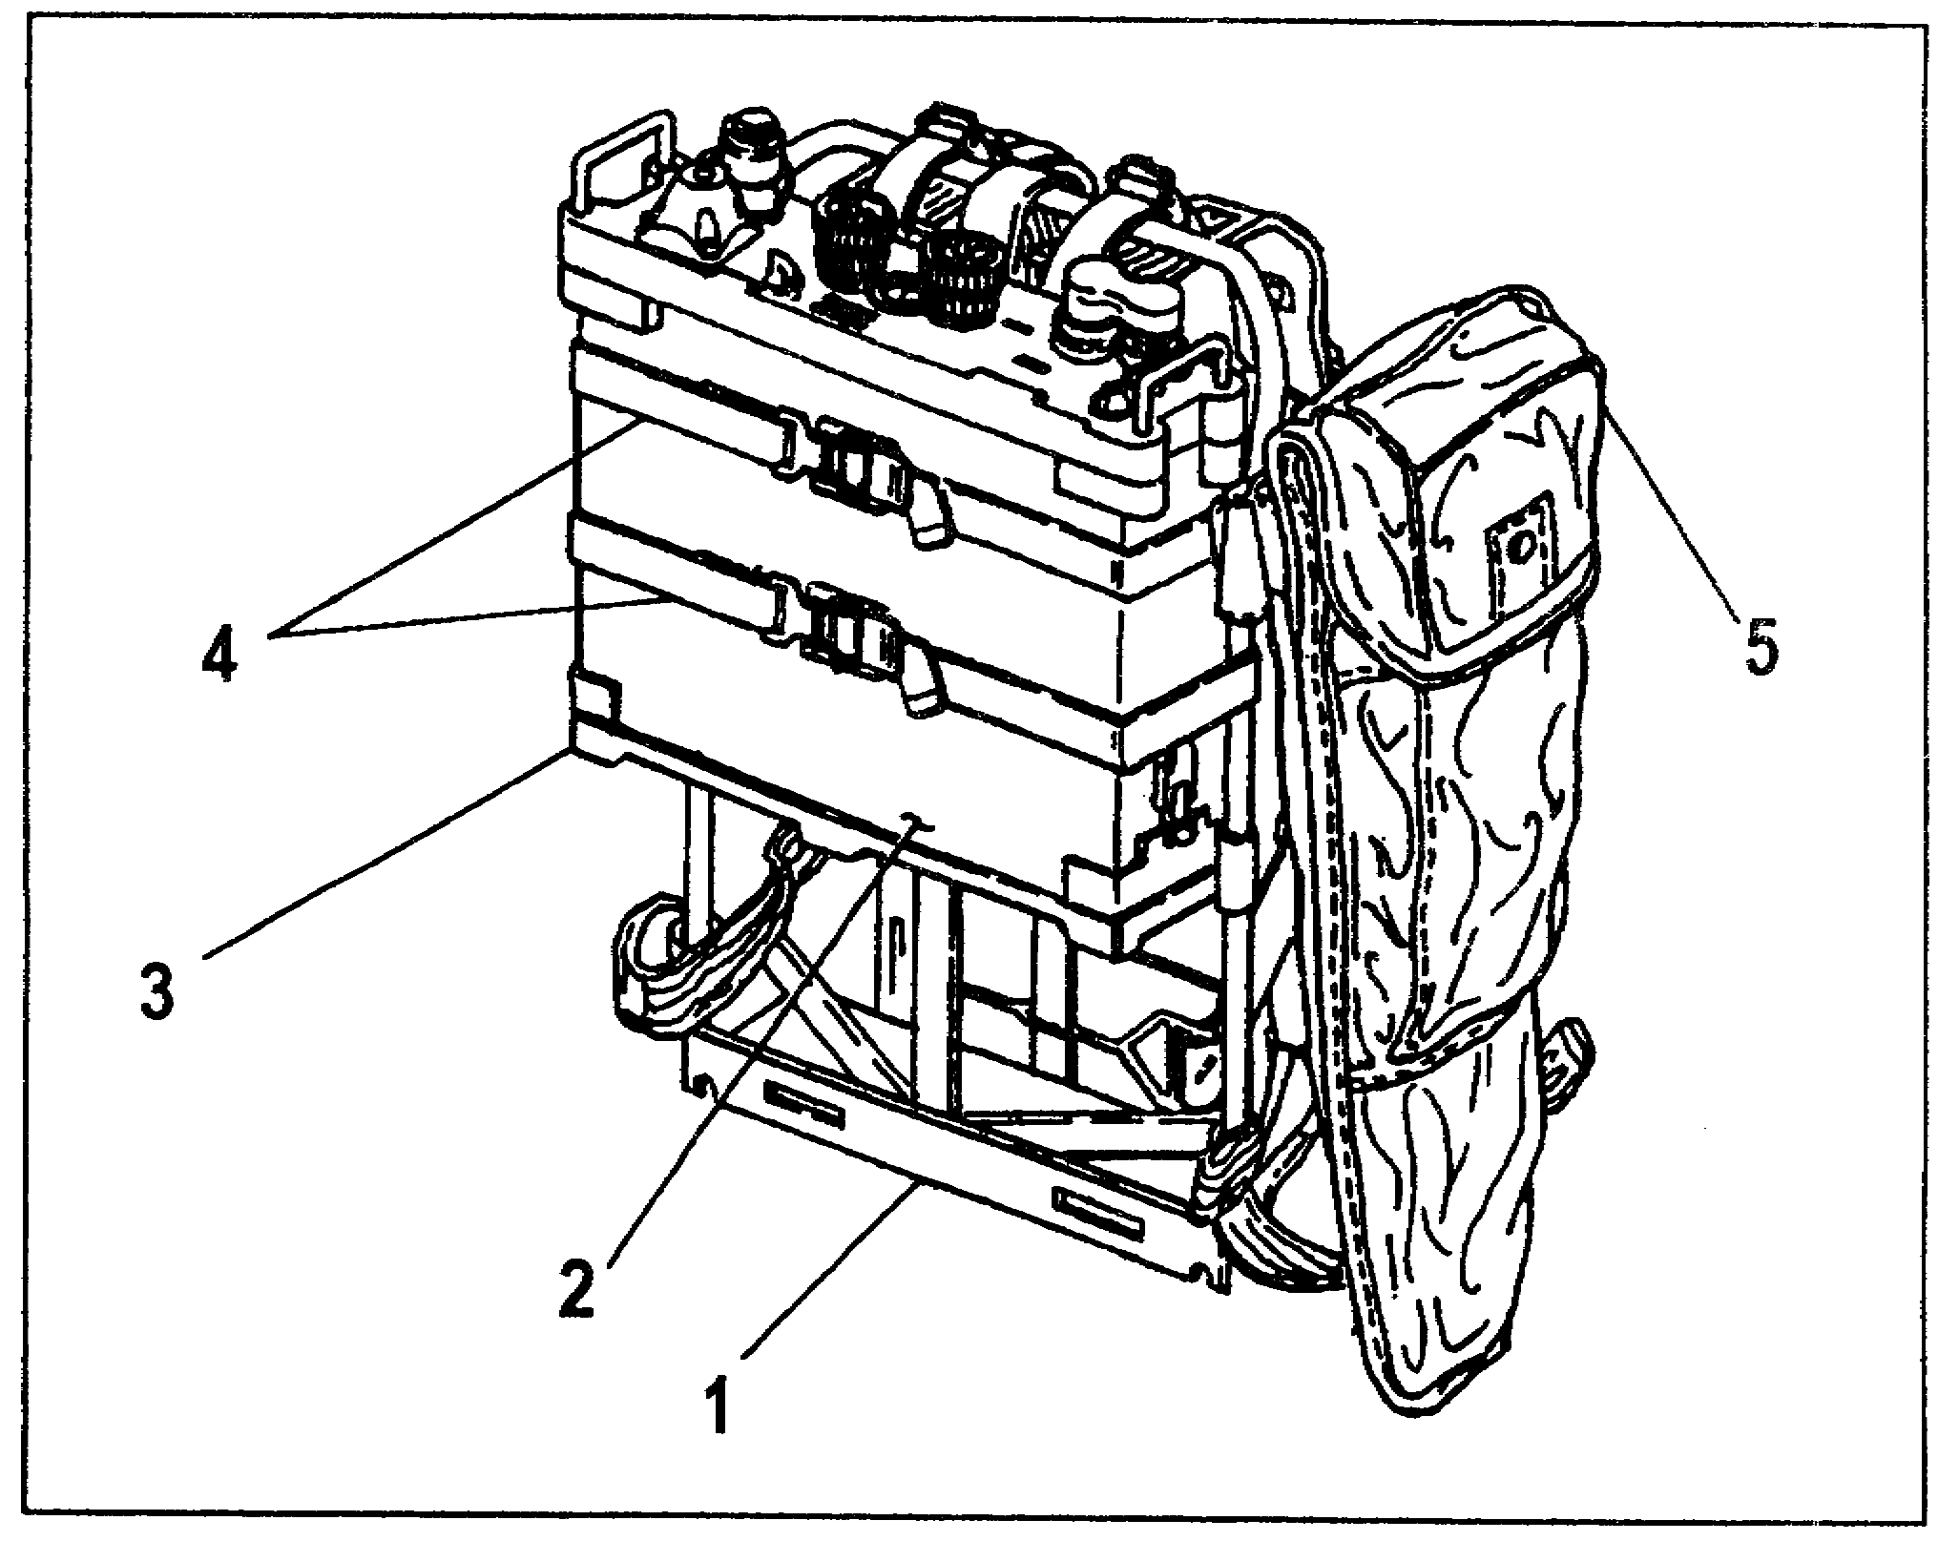

Figure 1-4. Radio set installed onto LC-2

(1) Place the LC-2 frame flat on a level surface with the cargo shelf (item 3) facing up.

(2) Place the RT (item 2) on the LC-2 with its front panel facing up and the battery box resting on the cargo shelf.

(3) Fasten the RT-841 to the LC-2 with the two cargo tiedown straps (item 4).

(4) Clip the equipment bag (item 5) to the upper cargo tiedown strap.

AD 0448 1-6

d. To install antennas, perform the following:

(1) At the antenna, AT-271A, (Figure 1-2, item 2, page 1-3), check to see that the tip is securely screwed into the bottom element. Screw the antenna base, AB-591, (item 6) into the ANT receptacle (Figure 1-1, item 4, page 1-2). Extend the antenna by unfolding it and inserting the sections individually by hand. Finally, screw the extended antenna into the receptacle on the antenna, AB-591.

(2) At the antenna, AT-892, (Figure 1-2, item 1, page 1-3), unfold and screw the blade section securely into the spring base section. Screw the spring base section securely into the whip ANT receptacle (Figure 1-1, item 4, page 1-2).

4. SUMMARY. This learning event covered the components of an AN/PRC-77. You were also instructed on how to attach the RT-841 to the harness to make the radio portable by a soldier and on how to install the whip antennas.

1-7 AD 0448

LEARNING EVENT 2: Operate the AN/PRC-77

1. GENERAL. This learning event will provide instruction on the operator controls and how these controls are used to operate the AN/PRC-77.

a. The RT-841 (Figure 1-5) receives and transmits signals.

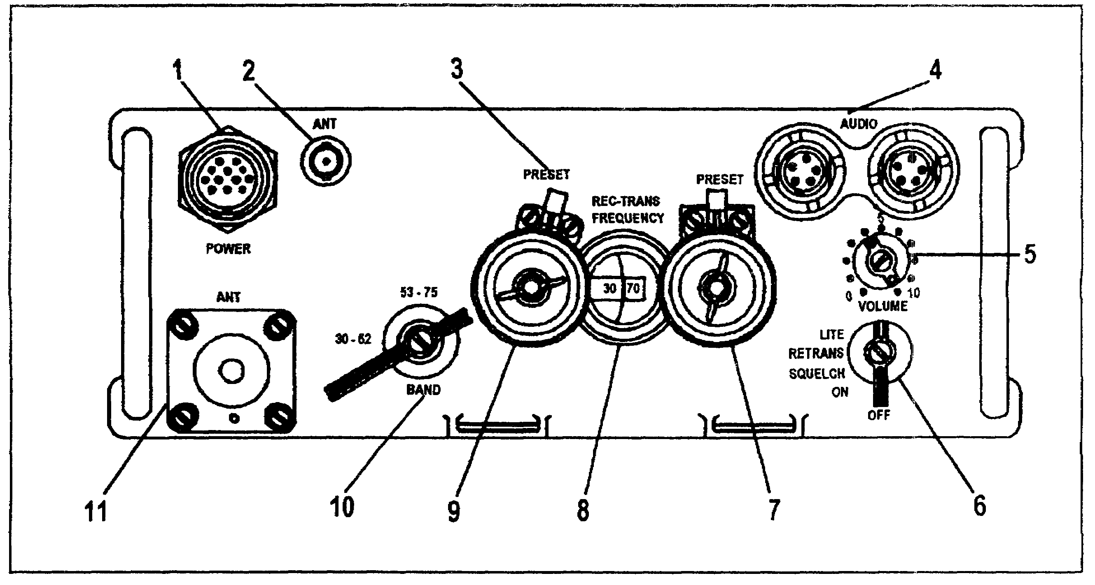

Figure 1-5. Receiver-transmitter, RT-841

(1) The POWER connector (item 1) provides for an external power supply when the RT-841 is used as part of a vehicular radio set.

(2) The ANT connector (item 2) permits the attachment of a vehicular antenna.

(3) The PRESET levers (item 3) permit rapid location of two preset frequencies.

(4) The AUDIO connectors (item 4) provide for the hookup of a handset or a relay/retransmission cable.

(5) The VOLUME control knob (item 5) changes the receiver volume.

AD 0448 1-8

(6) The function switch (item 6) has five positions as listed below.

(a) The OFF position turns off the radio power.

(b) The ON position turns on the radio power.

(c) The SQUELCH position turns on the radio power and stops the rushing noise heard when no signal is being received.

(d) The RETRANS position permits the radio to function in a relay mode.

(e) The LITE position is spring loaded and illuminates the numbers found on the REC-TRANS FREQUENCY dial (item 8).

(7) The Khz tuning control (item 7) tunes the RT-841 in 50 Khz steps as indicated by the REC-TRANS FREQUENCY dial.

(8) The REC-TRANS FREQUENCY dial (item 8) indicates the operating frequency in Mhz and Khz.

(9) The Mhz tuning control (item 9) tunes the RT-841 in 1 Mhz steps as indicated by the REC-TRANS FREQUENCY dial.

(10) The BAND switch (item 10) has two positions as listed below:

(a) The A band is the lower frequency and allows the radio to operate in the 30-52 Mhz range.

(b) The B band is the higher frequency and allows the radio to operate in the 53-75 Mhz range.

(11) The ANT mount (item 11) permits the attachment of the AT-271A and the AT-892 antennas.

b. OPERATING PROCEDURES. To operate the AN/PRC-77 (Figure 1-5, page 1-8) you need to know your call sign and what frequency to use. This information is usually classified, but can be obtained from the battery executive officer in the command post (CP). In the following situation, your assigned call sign will be W81 and the frequency will be 53:50.

1-9 AD 0448

(1) Set the function switch (item 6) to ON. A rushing noise should be heard in the handset.

(2) Set the BAND switch (item 10) to the B band 53-75 position. This is the frequency band containing your assigned frequency.

(3) Turn the Mhz (item 9) and Khz (item 7, tuning controls until the desired frequency (53:50) is indicated on the channel dial.

(4) Set the VOLUME control (item 5) at 4; readjust it, as necessary, for the desired sound level in the handset.

(5) Perform a communications check to determine if the radio operates. To transmit, follow these directions:

(a) Press the push-to-talk switch on the handset.

(b) Speak into the handset and say, "This is W81 commo check over."

(c) Release the push-to-talk switch to receive.

(6) Your radio is operational when you receive a message such as, "W81 this is XXX, roger out." This statement tells you that another station has received your messages and is responding.

NOTE: The receiver rushing noise can be eliminated by setting the function switch (item 6) to SQUELCH during periods when the other station is not transmitting.

2. SUMMARY. This learning event instructed you on the operating procedures for the AN/PRC-77.

LEARNING EVENT 3: Perform PMCS on the AN/PRC-77

1. GENERAL. PMCS are the systematic care, servicing, and inspection of equipment to prevent equipment failure. PMCS procedures are performed at specific intervals and under certain conditions. They ensure the equipment is ready for use.

AD 0448 1-10

NOTE: Before using the AN/PRC-77, verify that all of the components necessary for operation are on hand.

2. PMCS. Routine maintenance such as cleaning, dusting, washing, checking for frayed cables, loose nuts and bolts, loose switches and controls, damaged threads, stowing items not in use, and covering unused receptacles are not covered in detail in this lesson. You should look for these problems every time you use the radio.

a. Before Operation PMCS. Check to see that the battery case is not swollen or leaking and the contact receptacle is not damaged.

b. During Operation PMCS. There are four features you should check during operation:

(1) Check that the VOLUME control does not bind and there is not an interruption of received signals as the control is rotated through its range.

(2) Check that the squelch operation is satisfactory, if used.

(3) Check that your communication is not intermittent.

(4) Under normal conditions, check that communications can actually be conducted.

c. After Operation PMCS. Check to see that the battery case is not swollen or leaking and that the contact receptacle is not damaged.

3. SUMMARY. In this learning event you were taught the before, during, and after operation PMCS you should perform on the AN/PRC-77.

1-11 AD 0448

PART B: OPERATION OF THE RADIO SET AN/GRC-160

LEARNING EVENT: Describe Placing the AN/GRC-160 into Operation

1. GENERAL. The AN/GRC-160 radio (Figure 1-6) is simply an RT-841 (item 1) mounted in a vehicle with an AM-2060 power supply (item 8). Only the additional actions necessary to mount and bring an AI/GRC-160 to operational. status are covered.

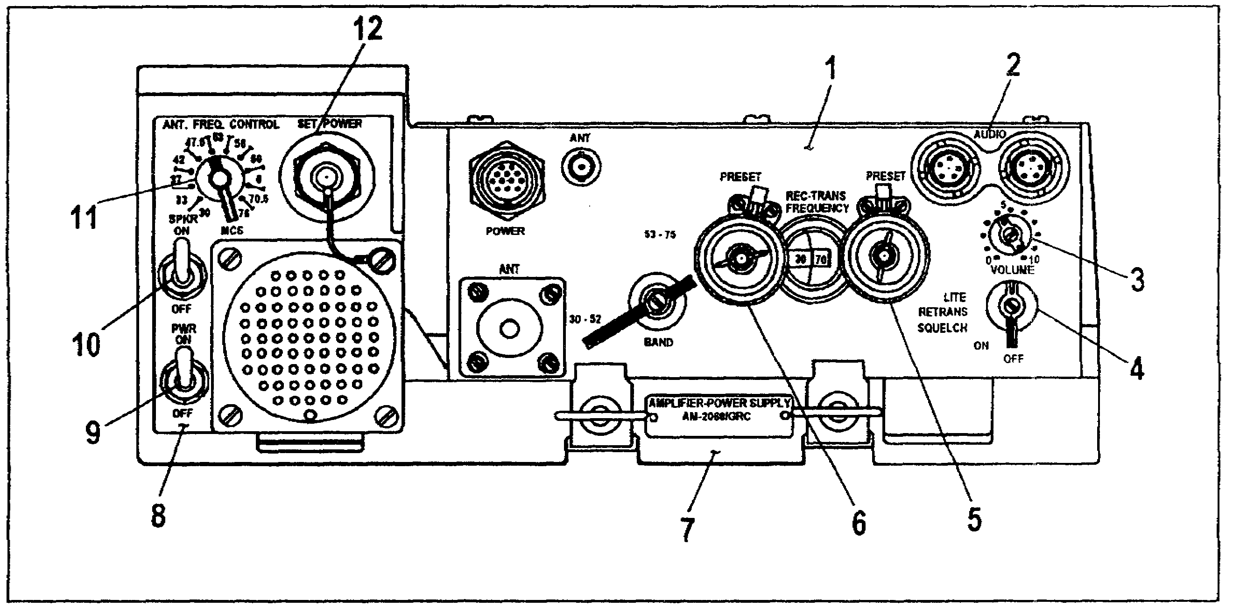

Figure 1-6. AN/GRC-160 with RT-841 mounted and AM-2060

2. SPECIAL INSTRUCTIONS. In a vehicle mounted situation, the RT-841 (item 1) is not operational by itself. It needs the following items to make it operational:

a. A power cable (not shown) for connection to the vehicular electrical system.

b. A radio mount (item 7).

c. An RF cable and a control cable (not shown) between the RT and the whip antenna.

d. Audio accessories for talking and listening (not shown).

AD 0448 1-12

e. A 22-28 VDC power source, AM-2060, (item 8).

(1) The PWR switch (item 9) acts as a 4-amp circuit breaker and turns the equipment on and off.

(2) The SPKR switch (item 10) connects and disconnects the speaker.

(3) The ANT FREQ CONTROL switch (item 11) is rotated to select the proper tuning network for the antenna, AS-1729, (Figure 1-8, page 1-15).

(4) The ANTENNA CONTROL connector (located on back panel) provides for the connection of the CX-4722 cable to the antenna AS-1729.

(5) The SET POWER connector (item 12) provides for the connection of the RT-841 to the OA-3633 amplifier-power supply group.

3. OPERATIONAL ITEMS.

a. The amplifier power supply group, OA-3633/GRC, consists of an amplifier-power supply AM-2060 (Figure 1-6, item 8) and a radio mount (item 7). The CX-4655 cable assembly provides interconnection between the installed RT-841 and the AM-2060 power supply. It allows for the passage of dc power, audio signals, and control signals. The AM-2060 provides operating voltages for the RT-841 and contains a speaker for hearing received radio signals.

1-13 AD 0448

b. The mounting plate, MT-1029, (Figure 1-7) provides electrical power for the amplifier power supply group, OA-3633. It has five resilient shock absorbers (item 1) which protect the radio from bouncing and jarring. Two clamps (item 2) are used to lock the 0A-3633 into the MT-1029. The mounting plate has a gasket-sealed junction box (item 3) with connectors to provide for the distribution of power, control, and signal voltages.

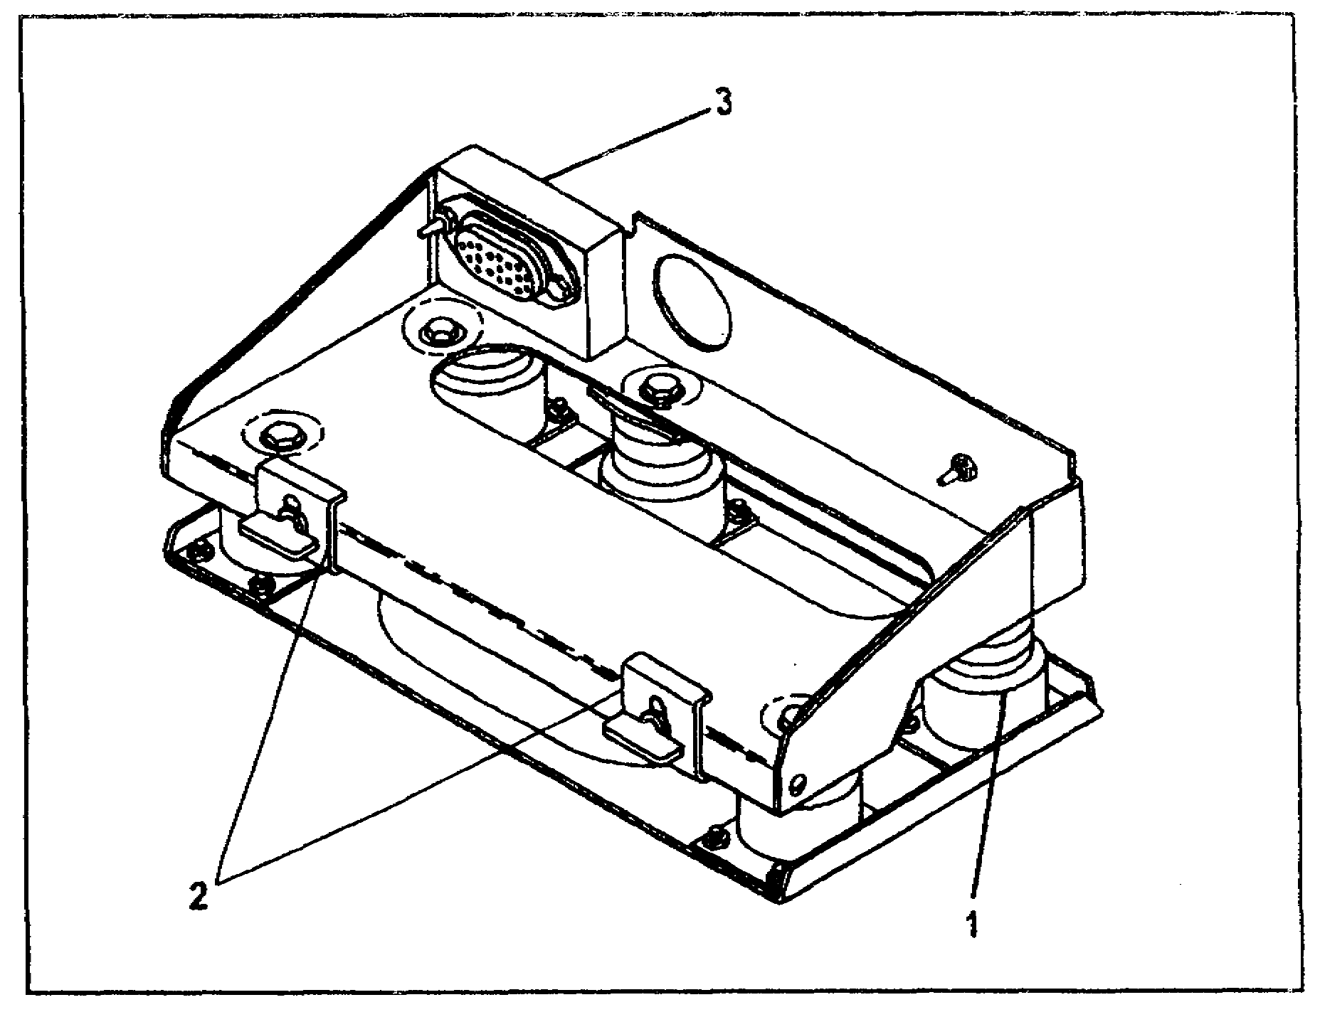

Figure 1-7. Mounting plate, MT-1029

c. The antenna, AS-1729, (Figure 1-8) is mounted on vehicles. Two antenna elements (item 1) are screwed together and attached to the MX-6707 matching unit (item 2). The matching unit contains antenna tuning networks for 10 frequency bands (item 3). The proper network is automatically selected by the amplifier power supply control group. The antenna elements are made of rigid fiberglass in which a basket weave radiating metal is imbedded. When assembled, the antenna elements are 9½ feet long. The AS-1729 has two cable connectors and one band control knob (item 4). The band control knob is not used by the operator. The RF antenna cable is connected to J1 (item 5) and the control signal cable is connected to J2 (item 6).

AD 0448 1-14

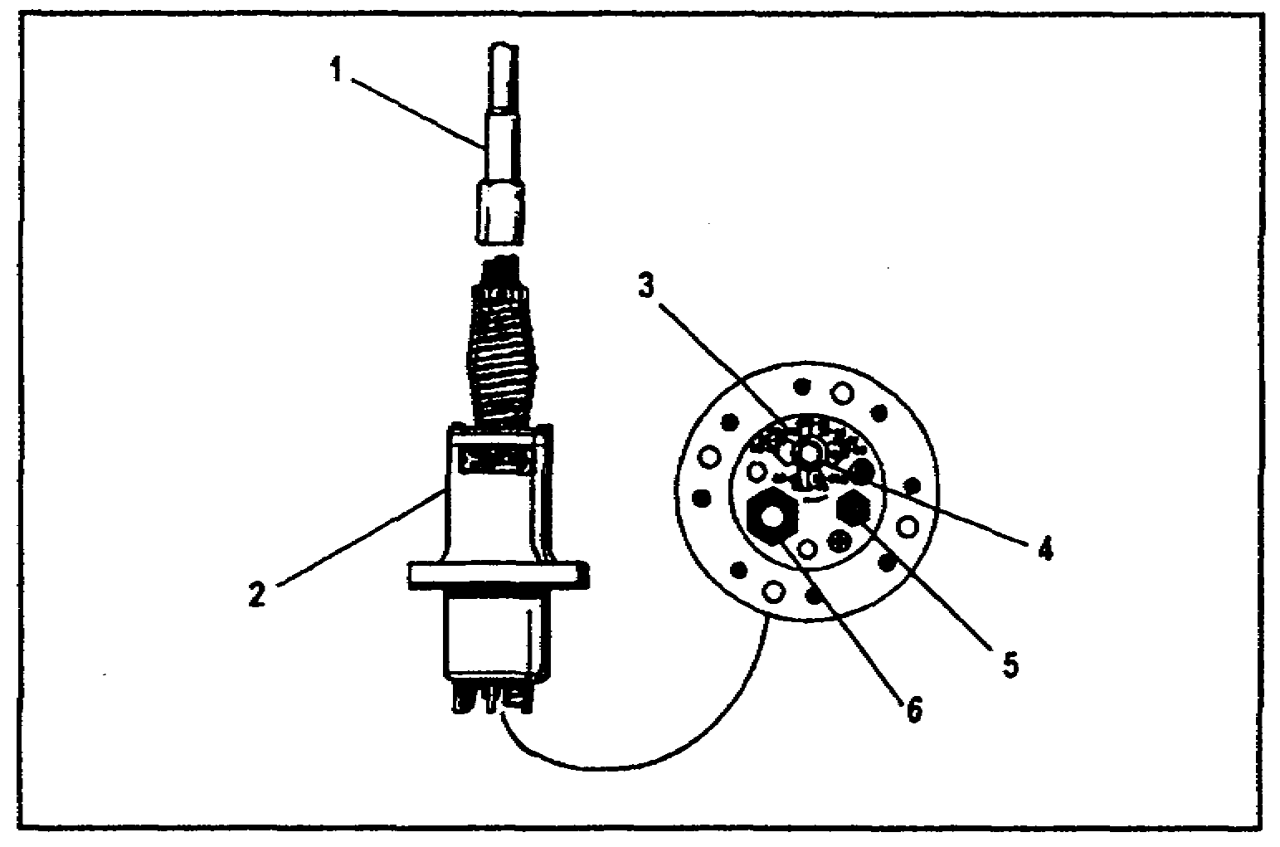

Figure 1-8. AS-1729, antenna lower portion

4. OPERATING PROCEDURES FOR THE AN/GRC-160.

a. Connect the handset or microphone to either of the two RT audio connectors (Figure 1-6, item 2, page 1-12).

b. Turn the function switch (item 4) ON.

c. Turn the amplifier-power supply PWR switch (item 9) ON.

d. Adjust the volume on the RT volume control (item 3) until a rushing noise is heard.

e. If squelch operation is desired, turn the function switch (item 4) on the RT-841 to SQUELCH.

f. If the AM-2060 speaker is to be used, set the SPKR switch (item 10) to ON and adjust the VOLUME control to a desired listening level.

g. Use the Mhz (item 6) and Khz (item 5) tuning controls to set the assigned frequency.

h. Turn the ANT FREQ control (item 11) to the position that includes the selected operating frequency.

5. SUMMARY. You learned that the AN/GRC-160 is the same radio as the AN/PRC-77, except that it has a few additional items and is installed in a vehicle instead of being carried by a soldier. You also learned what these items are and how to operate them.

1-15 AD 0448

LESSON 1

PRACTICE EXERCISE

The following items will test your comprehension of the material covered in this lesson. There is only one correct answer for each item. When you complete the exercise, check your answers with the answer key that follows. If you answer any item incorrectly, review the part of the lesson which contains the portion involved.

1. Which item is the "heart" of an AN/PRC-77 radio?

A. CY-2562.
B. AM-2060.
C. RT-841.
D. OA-3633.

2. Which antenna should you use with the AN/PRC-77 when you desire maximum range?

A. AT-892.
B. AT-271A.
C. AB-591A.
D. AS-1729.

3. Which antenna should you use with the AN/PRC-77 for short-range service?

A. AT-271A.
B. AT-892.
C. AB-591-A.
D. AS-1729.

4. Which battery box should you use with the RT-841?

A. CY-2562.
B. CX-4720.
C. CX-4671.
D. CX-2562.

1-17 AD 0448

5. The BAND switch on an RT-841 has how many positions?

A. Four.
B. Three.
C. Two.
D. One.

6. In what range does the A band position of the BAND switch allow the radio to operate?

A. 30-52 Mhz range.
B. 53-75 Mhz range.
C. 76-93 Mhz range.
D. 95-110 Mhz range.

7. When performing PMCS on the AN/PRC-77, when should you inspect the VOLUME control?

A. Before operation only.
B. After operation only.
C. During operation only.
D. Before, during and after operation.

8. Which switch on the AM-2060 should you rotate to select the proper tuning network on the antenna, AS-1729?

A. Mhz control.
B. Khz control.
C. BAND switch.
D. ANT FREQ CONTROL.

9. Which mounting plate is used with a AN/GRC-160?

A. MT-1898.
B. MT-1029.
C. MT-4626.
D. AB-15.

10. Which antenna should you use with the AN/GRC-160?

A. AB-15.
B. MX-6707.
C. AS-1729.
D. AT-271A.

1-19 AD 0448

LESSON 1
PRACTICE EXERCISE
ANSWER KEY AND FEEDBACK

Item Correct Answer and Feedback

1. C. RT-841.

Page 1-2, para 2.

2. B. AT-271A.

Page 1-3, para 2b (2).

3. B. AT-892.

Page 1-3, para 2b (1).

4. A. CY-2562.

Page 1-5, para 3b (6).

5. C. Two.

Page 1-9, para 1a (10).

6. A. 30-52 Mhz.

Page 1-9, para 1a (10)(a).

7. C. During operation only.

Page 1-11, para 2b (1).

8. D. ANT FREQ CONTROL.

Page 1-13, para 2e (3).

9. B. MT-1029.

Page 1-14, para 3b.

10. C. AS-1729.

Page 1-14, para 3c.

1-21 AD 0448

LESSON 2

RADIO SETS AN/VRC-46 AND AN/VRC-47

CRITICAL TASKS: 113-587-2064
113-587-2063
113-622-2013

OVERVIEW

LESSON DESCRIPTION

In this lesson you will learn how to operate the AN/VRC-46 and AN/VRC-47 radio sets, and how to operate a radio set from a remote location using the AN/GRA-39.

ENABLING LEARNING OBJECTIVES:

ACTION: You will identify the components and describe the operation of an:

(1) AN/VRC-46 radio set with TSEC/KY-57.

(2) AN/VRC-47 radio set with TSEC/KY-57.

(3) AN/GRA-39 radio set control group.

CONDITION: You will be given textual information and illustrations within the AD 0448 subcourse booklet.

STANDARD: To demonstrate competency of the instructions contained in this lesson, you must achieve a minimum score of 70% on the subcourse examination.

REFERENCES: The material contained in this lesson was derived from the following publications: STP 44-16T1-SM, STP 44-24T1-SM, TM 11-5820-401-10-1, TM 11-5820-401-10-2, and TM 11-5820-477-12.

INTRODUCTION

When a Patriot unit communicates from the battery, it uses an AN/VRC-46 or AN/VRC-47 radio. Sometimes, you will need to set up remote VHF communications, this is accomplished using the radio set control group AN/GRA-39.

2-1 AD 0448

PART A: OPERATION OF THE RADIO SET AN/VRC-4C

LEARNING EVENT: Describe the Components of the Radio Set AN/VRC-46

1. GENERAL. The AN/VRC-46 is the most widely used radio set in a Patriot unit. This radio is used in the ECS, battery maintenance center (BMC), communications relay group (CRG) information and coordination central (ICC), CP, and most of the M1008A1 trucks containing radios. A knowledge of how to operate this radio is essential.

2. AN/VRC-46 COMPONENTS.

a. The electrical power requirement is 22-28 VDC.

b. The receiver-transmitter, RT-524, (Figure 2-1) is a rugged and compact FM radio that provides radio communications on a push-to-talk basis.

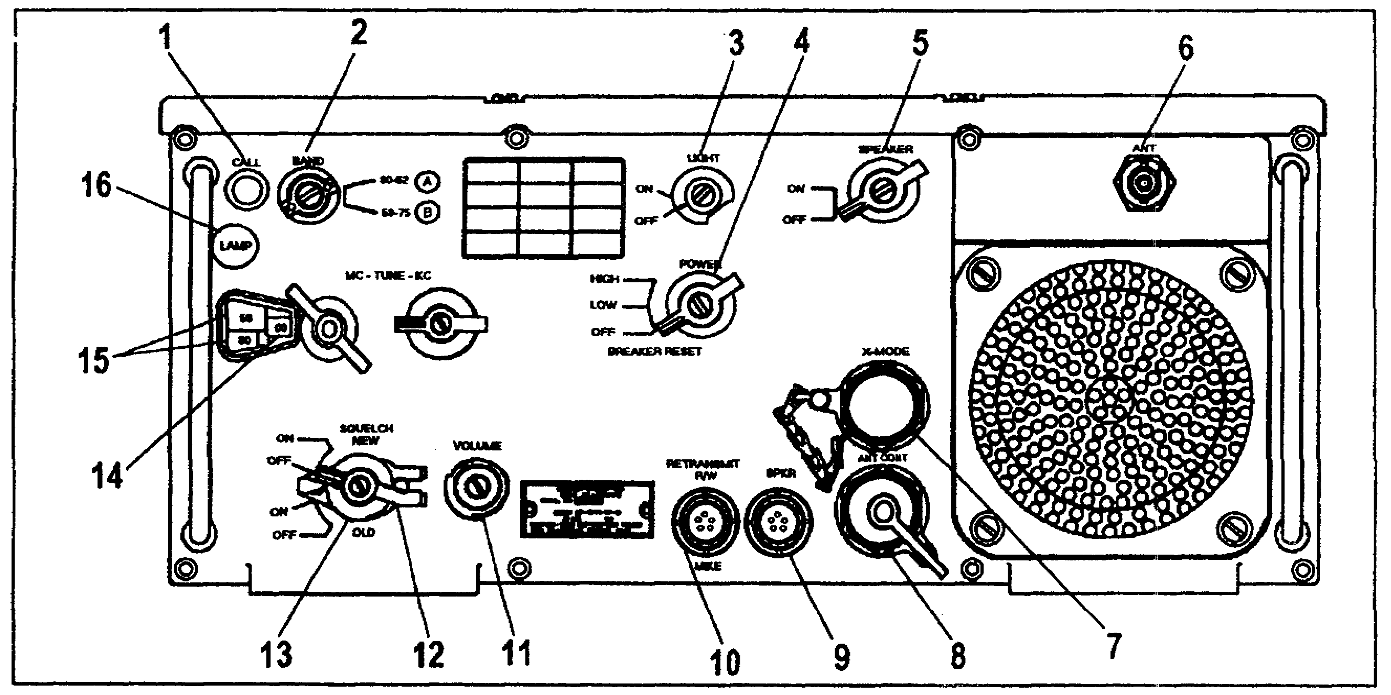

Figure 2-1. Receiver-transmitter, RT-524

(1) The CALL indicator (item 1) will illuminate to indicate that a signal is received.

(2) The BAND switch (item 2) is used to select the frequency band from either A or B band.

AD 0448 2-2

(3) The LIGHT switch (item 3) controls DC power to the dial light and CALL indicator.

(4) The POWER switch (item 4) controls DC power to the radio and has the following three positions:

• OFF: All DC power is off.

• LOW: Turns on DC power to the radio. When the radio is transmitting, it outputs on low RF power (.5 to 8 watts).

• HIGH: Turns on DC power to the radio. When the radio is transmitting, it outputs on high RF power (35 watts minimum).

(5) The SPEAKER switch (item 5) controls the speaker.

(6) The ANT connector (item 6) is a BNC RF cable connector that allows RF signals to flow to the AS-1729.

(7) The X-MODE connector (item 7) provides for the attachment of a security unit, TSEC/KY-57 to the radio.

(8) The ANT CONT connector (item 8) provides for the attachment of the RT-524 to the AS-1729 using the cable, CX-4722. Control of the AS-1729 tuning networks is automatic and occurs when the MC control and BAND switches are moved.

(9) The SPKR connector (item 9) provides for the following connections:

- Any audio accessory such as a microphone or a headset.

- A loud speaker for radio reception.

(10) The RETRANSMIT R/W connector (item 10) provides for the attachment of the following:

- Any audio accessory such as a microphone or a headset.

- A retransmission cable when the RT is a part of a AN/VRC-49.

2-3 AD 0448

- A radio/wire integration cable for radio transmission and reception to be controlled by a field telephone.

(11) The VOLUME control (item 11) regulates audio output of the speaker.

(12) The SQUELCH latch (item 12), when pushed to the right, confines the SQUELCH switch to either the two upper or the two lower positions.

(13) The SQUELCH switch (item 13) will silence the rushing noise in the speaker when in the NEW ON position. The OLD ON/OFF position is not used.

(14) The KC numbers control (item 14) provides manual tuning of the radio in .05 Mhz steps.

(15) The MC numbers control (item 15) provides manual tuning of the radio in 1 Mhz steps.

(16) The LAMP holder (item 16) holds the light that illuminates the dial.

c. The antenna, AS-1729, (Figure 1-8, page 1-15) uses two antenna elements (item 1) which are screwed together and then mounted on a matching unit (item 2) containing antenna tuning networks for 10 frequency bands (item 3). The proper tuning network is automatically selected by the tuning circuits of the RT.

AD 0448 2-4

d. The security unit, TSEC/KY-57, (Figure 2-2) is a small, light-weight, wide-band, secure voice digital communications device. It is designed for use with all FM radios. It is a push-to-talk device operating at 16,000 bits per second. It will encrypt transmitted voice signals and decrypt received voice signals.

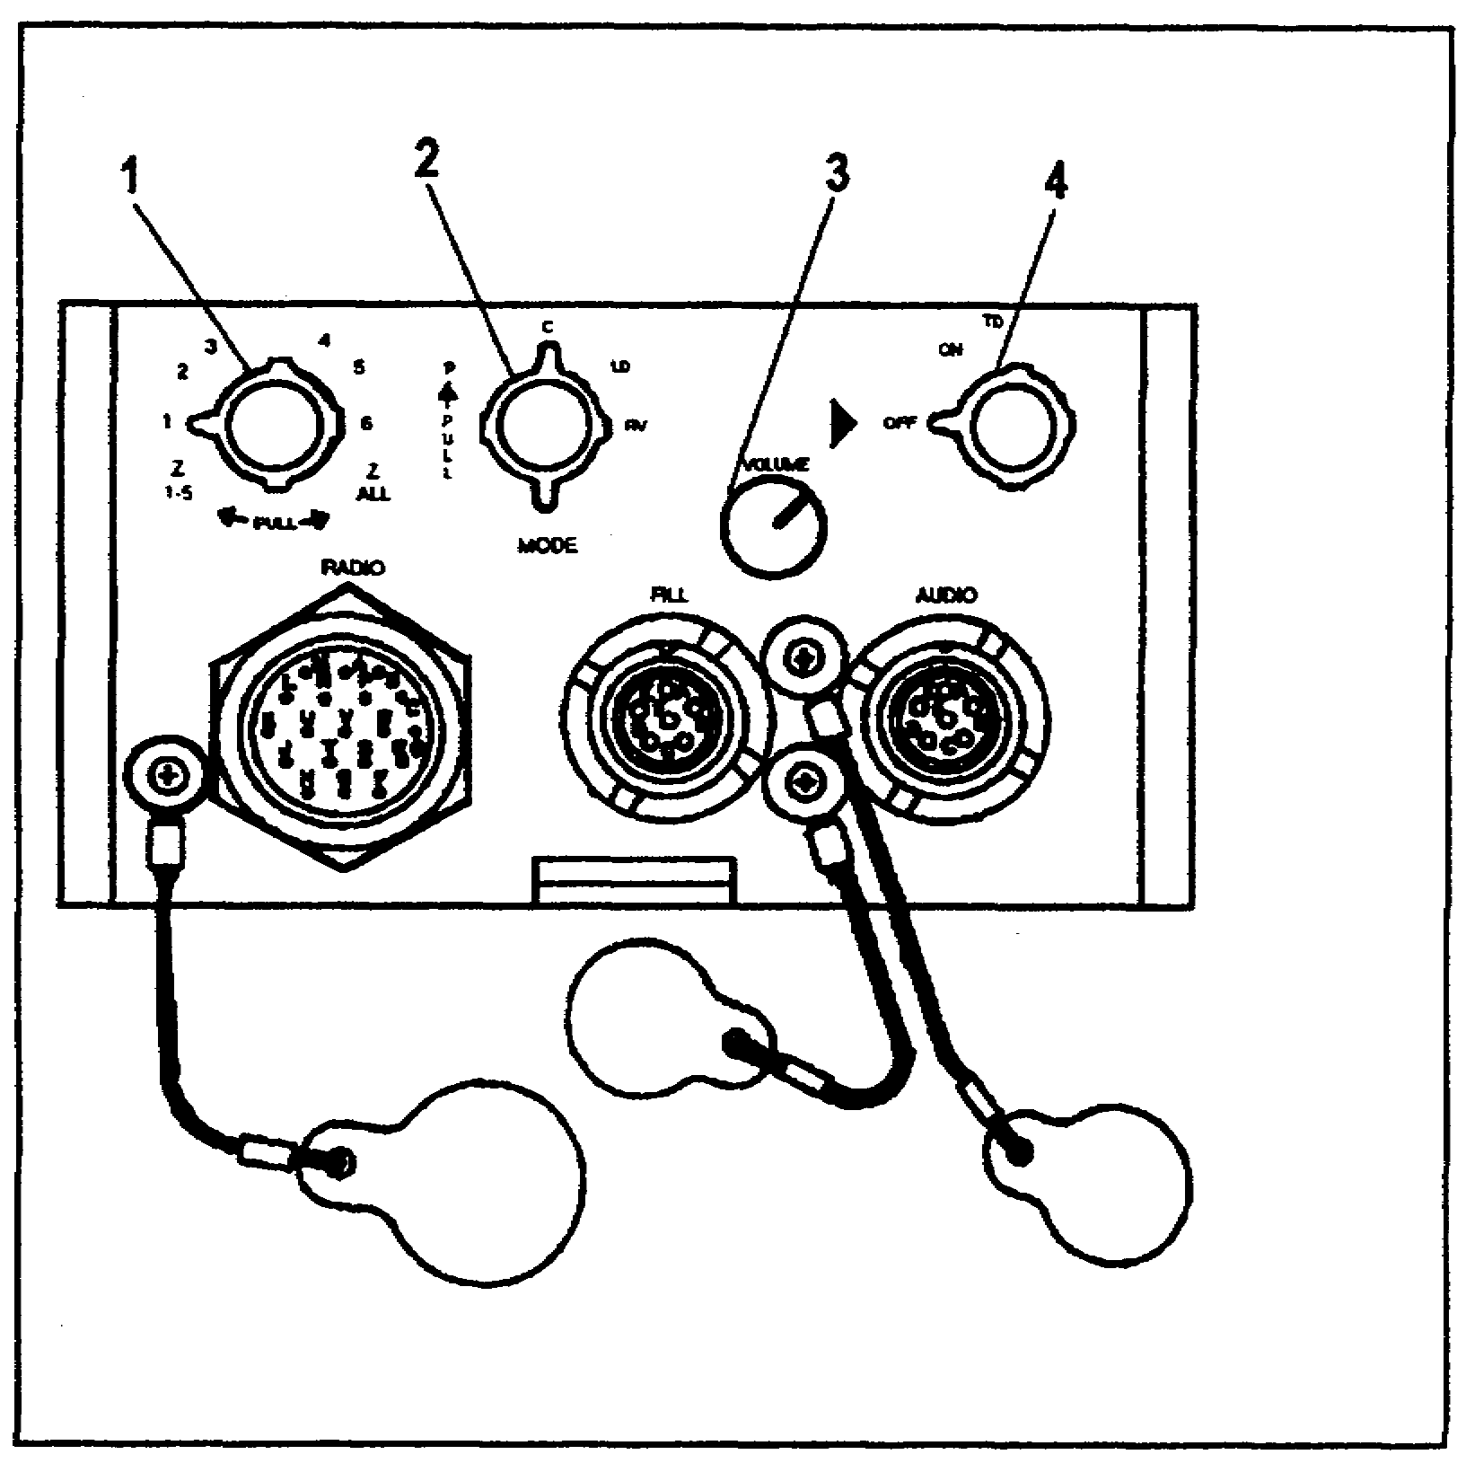

Figure 2-2. Security unit, TSEC/KY-57

(1) The FILL switch (item 1) is used to select desired encrypting circuits in the TSEC/KY-57. You can also erase or "zero" the circuits with this switch.

(2) The MODE switch (item 2) allows the operator to select one of four possible operating modes.

- P or plain text mode. No audio signals are encrypted or decrypted.

- C or cipher mode. All outgoing audio signals are encrypted. Any received, encrypted message will be decrypted.

2-5 AD 0448

- LD of load mode. This mode is used when you are loading the encrypting circuits with the code for the day.

- RV or remote variable mode. This mode is not used by Patriot units.

(3) The VOLUME control (item 3) works in unison with the other volume controls on the radio.

(4) The power switch (item 4) has three positions.

- ON: Applies DC power to the KY-57.

- OFF: Removes DC power.

- TD: Not used in Patriot units.

e. The mounting plate, MT-4626, (Figure 2-3) is used to secure the TSEC/KY-57.

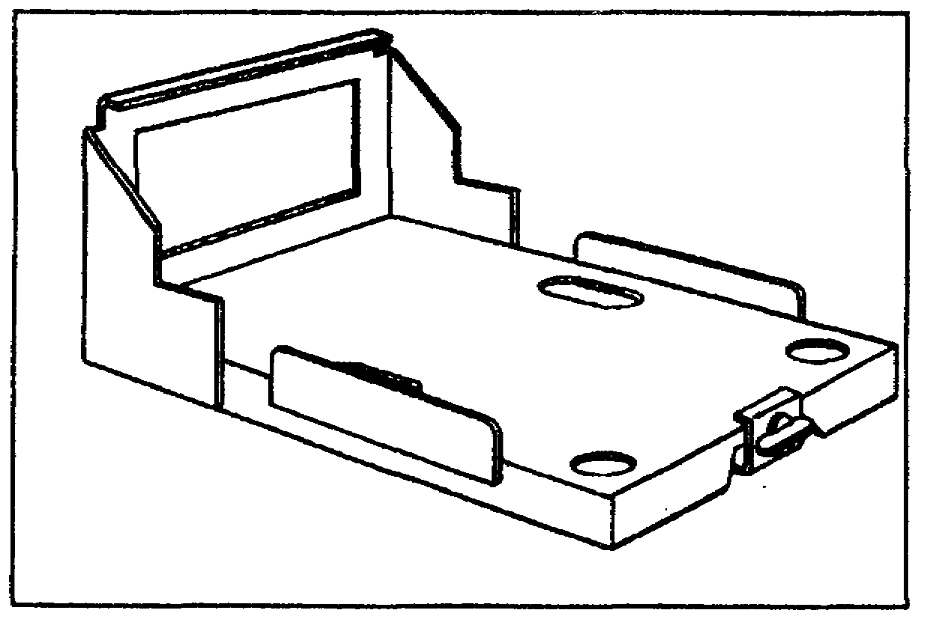

Figure 2-3. Mounting plate, MT-4626

f. The mounting plate, MT-1029, (Figure 1-7, page 1-14) is used to secure and install the receiver-transmitter.

(1) The MT-1029 is bolted to the vehicle and the RT is then installed and clamped on it. Each mounting plate has a connector which mates with the connector at the rear of the RT. This connector provides for the passage of power and received/transmitted audio signals between the RT and other equipment such as the TSEC/KY-57.

AD 0448 2-6

(2) When the TSEC/KY-57 is used, a J-3513A inter-connecting junction box (Figure 2-4, item 1) must be installed on the MT-1029. The J-3513A allows the TSEC/KY-57 to be cabled to the RT.

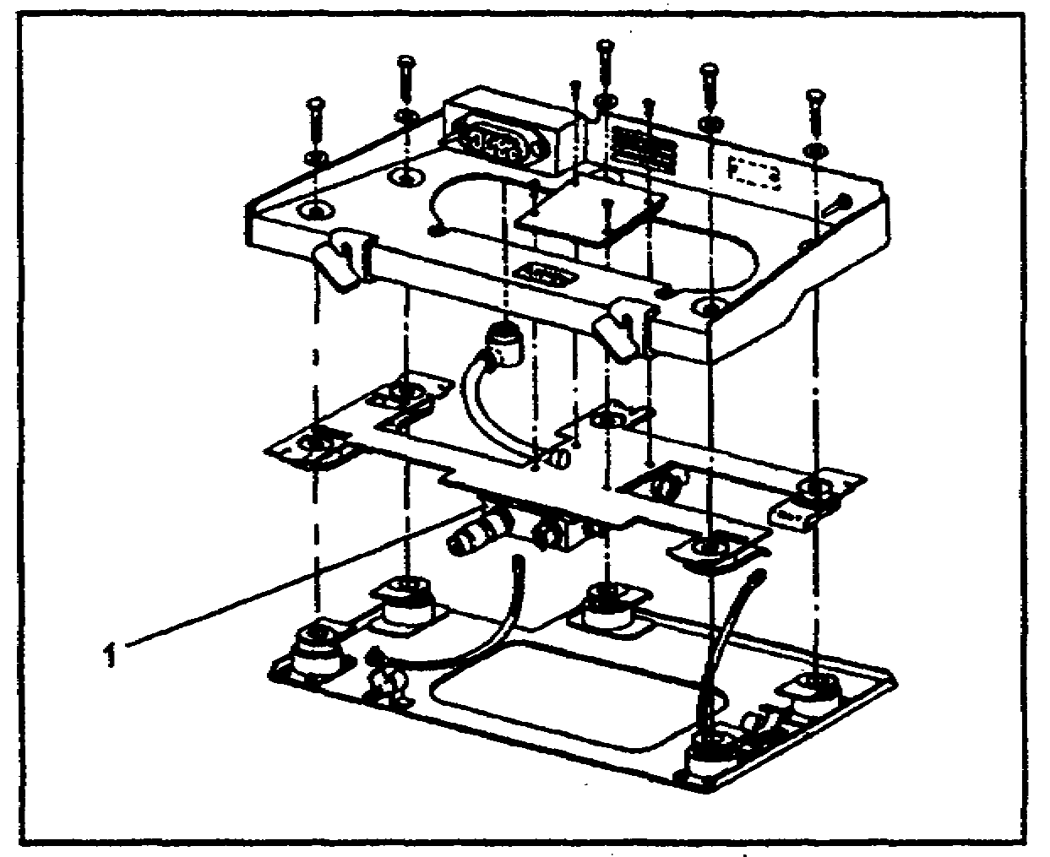

Figure 2-4. Interconnecting box J-3513A installation

g. The hand held microphone, M-80, with a push-to-talk switch is used with the AN/VRC-46 radio set.

h. Cable CX-4720 is the interconnecting cable that carries power from the vehicle electrical system to the mounting plate, MT-1029.

3. OPERATION OF THE AN/VRC-46. The operator must perform the following to operate the AN/VRC-46 with the TSEC/KY-57.

a. Connect the handset to the J-3513A junction box (Figure 2-4, item 1) mounted with the mounting plate, MT-1029.

b. At the TSEC/KY-57 (Figure 2-2, page 2-5):

(1) Set the power switch (item 4) to ON.

(2) Place the MODE switch (item 2) to C.

(3) Set the VOLUME control (item 3) to mid-range.

(4) Set the FILL switch (item 1) to the position that contains the codes for the day.

2-7 AD 0448

c. At the RT-524 (Figure 2-1, page 2-2):

(1) Turn the POWER switch (item 4) to LOW.

(2) Set the SQUELCH switch (item 13) to OFF.

(3) Set the SPEAKER switch (item 5) to ON.

(4) Adjust the VOLUME control (item 11) to the desired listening level.

(5) Set the SQUELCH switch to NEW ON.

(6) Set the BAND switch (item 2) to select either the A or B frequency.

(7) Set the MC and KC controls (items 14 and 15) to the desired frequency.

d. To transmit a message over the radio, press the push-to-talk switch on the microphone and speak into the microphone element.

e. To receive a message release the push-to-talk switch and listen to the speaker.

4. SUMMARY. This learning event provided instructions on how to operate the AN/VRC-46 radio set. You learned about the individual items that make up a AN/VRC-46 and the purpose of each. Finally, you learned how to place the radio set into operation.

PART B: OPERATION OF THE RADIO SET AN/VRC-47

LEARNING EVENT: Describe the Components of the Radio Set AN/VRC-47

1. GENERAL. The AN/VRC-47 has been used by Patriot units for many years. The only differences between the AN/VRC-46 and AN/VRC-47 are the receiver (R-442), its antenna, and related cables. This radio set allows two frequencies to be monitored and lets the operator transmit on one frequency. This radio is compact and does not take up much space.

2. AN/VRC-47 COMPONENTS.

a. The electrical power requirement is 22-28 VDC.

AD 0448 2-8

b. This radio set requires two antennas to allow the monitoring of two frequencies.

(1) The antenna, AB-15, (Figure 2-5) is designed for receiving FM signals only. It consists of three antenna elements: a CG-1773 antenna cable (item 1), an RF cable adapter, UG-273, (item 2) and a ceramic base piece (item 3).

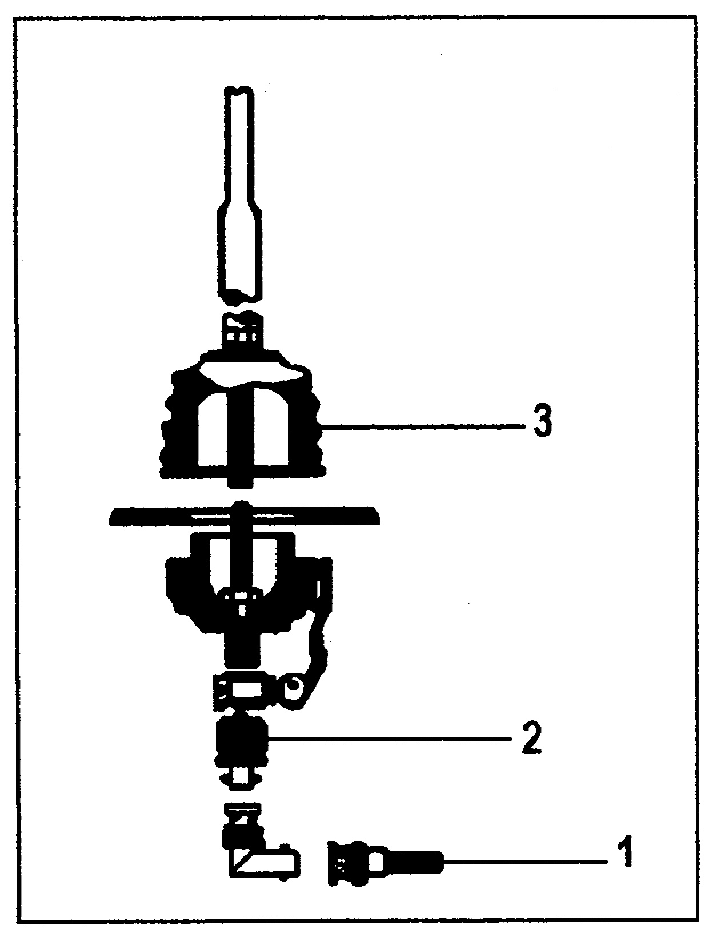

Figure 2-5. Antenna, AB-15

(2) The antenna, AS-1729, (Figure 1-8, page 1-15) was discussed in Lesson 1 and is not covered here.

2-9 AD 0448

c. The receiver, R-442, (Figure 2-6) is the portion of the AN/VRC-47 that receives signals from one frequency. It is cabled to the antenna, AB-15, with the CG-1773. The R-442 receives power from the mounting plate, MT-1898.

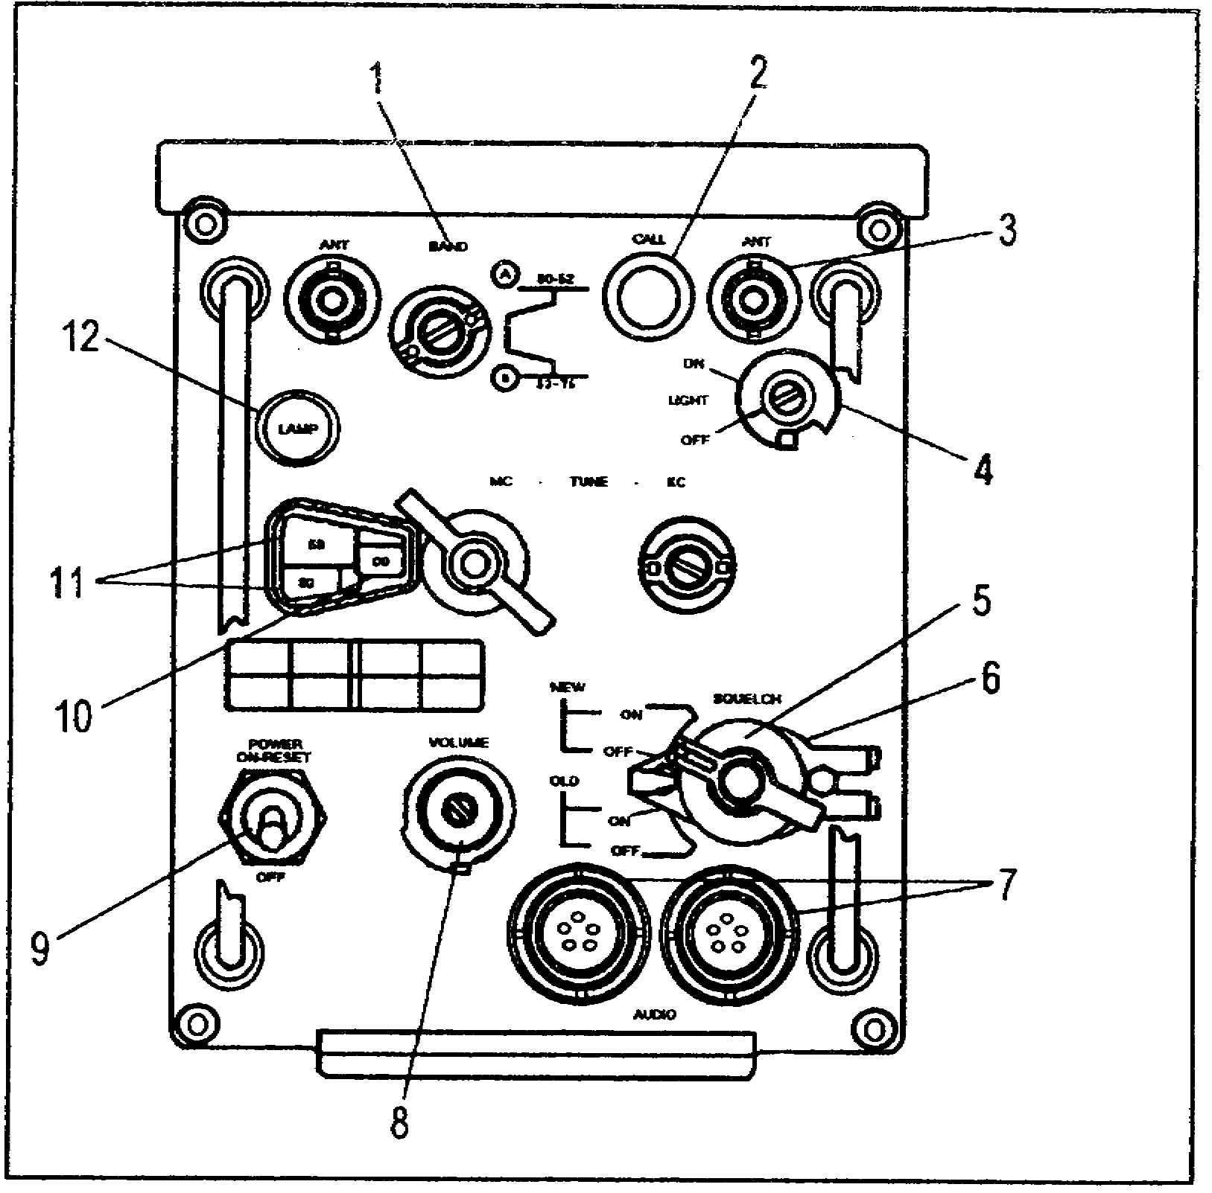

Figure 2-6. Receiver, R-442

(1) The BAND switch (item 1) is used to select the tuning frequency band from either A band (30.00 to 52.95 Mhz) or B band (53.00 to 75.95 Mhz).

(2) The CALL lamp (item 2) will illuminate to indicate that a signal is being received.

(3) The ANT connectors (item 3) provide for the attachment of an RF cable to connect the R-442 to the antenna, AB-15.

(4) The LIGHT switch (item 4) controls DC power to the dial window lamp and the call lamp.

(5) The SQUELCH switch (item 5) will silence the rushing noise in the speaker when in the NEW ON position. The OLD ON/OFF position is not used.

AD 0448 2-10

(6) The SQUELCH latch (item 6), when pushed to the right, confines the SQUELCH switch to the two upper or two lower positions.

(7) The AUDIO connectors (item 7) provide for the attachment of audio accessories.

(8) The VOLUME control (item 8) increases or decreases the audio output of the speaker.

(9) The POWER switch (item 9) controls DC power to the radio set.

(10) The KC numbers control (item 10) provides for manual tuning of the radio in .05 Mhz steps.

(11) The MC numbers control (item 11) provides for manual tuning of the radio in 1 Mhz steps.

(12) The dial LAMP holder (item 12) holds the light that illuminates the dial.

d. The mounting plate, MT-1898, (Figure 2-7) holds the receiver, R-442. An interconnecting junction box (item 1) is included on the MT-1898 for operating the R-442 with a TSEC/KY-57.

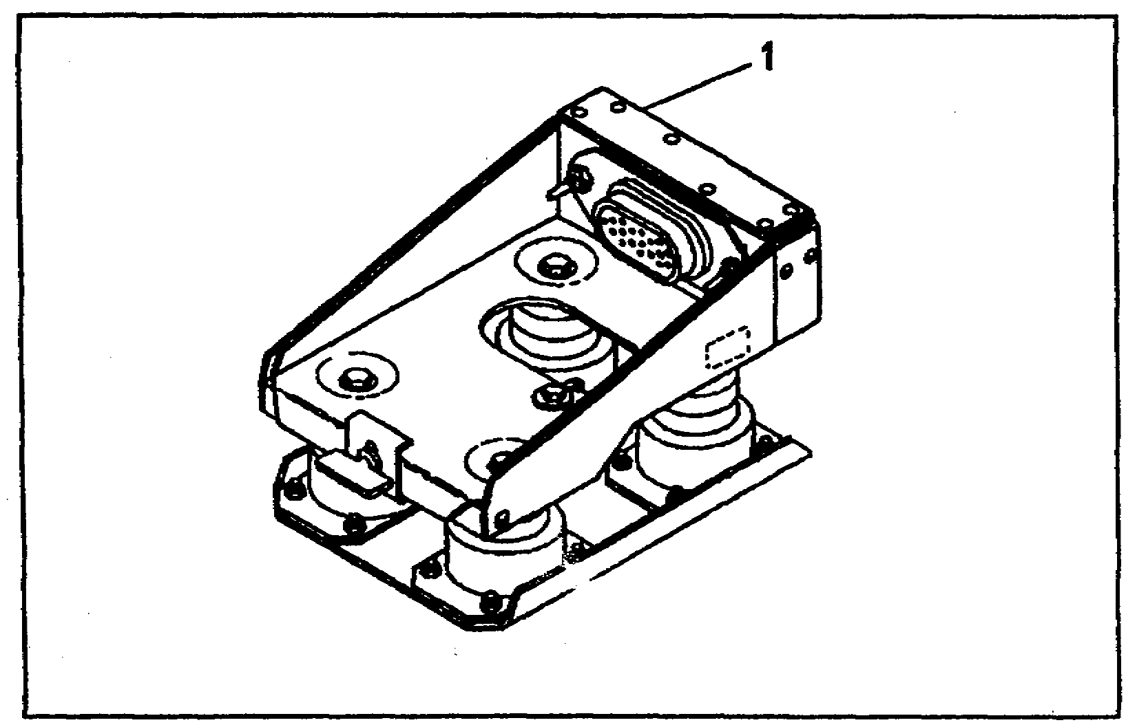

Figure 2-7. Mounting plate, MT-1898

e. The FM RT-524, (Figure 2-1, page 2-2) is capable of communicating in the same frequencies as the AN/PRC-77.

2-11 AD 0448

f. The security unit, TSEC/KY-57r (Figure 2-2, page 2-5) is an item of communications equipment that encodes and decodes voice signals that are transmitted/received. The AN/VRC-47 uses two of these to transmit and receive secure/encrypted messages.

g. The mounting plate, MT-4626, (Figure 2-3, page 2-6) is the mounting base used to secure the TSEC/KY-57.

h. The mounting plate, MT-1029, (Figure 1-7, page 1-14) was discussed in Lesson 1.

i. The hand held microphone, M-80, with a push-to-talk switch is used with the AN/VRC-47 radio set.

j. Cables CX-4720 and CX-4721 are the interconnecting cables that carry power from the vehicle electrical system to the mounting plates MT-1029 and the MT-1898.

4. OPERATION OF THE AN/VRC-47. Only the operation of the R-442 (Figure 2-6, page 2-10) will be addressed in this lesson. The operation of the remaining components was covered in Part A with the AN/VRC-46.

a. Verify the CX-4721 cable assembly is connected between the mounting plates MT-1029 and the MT-1898. Check that the security unit, TSEC/KY-57, has been loaded and is connected properly to the receiver, R-442, with the special purpose cable assembly. Ensure the CG-1773 antenna cable is properly attached to the antenna base, AB-15 and one of the ANT receptacles (item 3) on the receiver, R-442.

b. At the receiver, R-442:

(1) Set the SQUELCH switch (item 5) to OFF.

(2) Rotate the VOLUME control (item 8) fully counter-clockwise.

(3) Select the BAND switch (item 1) position (A or B) that will support the assigned frequency.

(4) Dial in your frequency using the MC knob (item 11).

(5) Set the POWER switch (item 9) to ON.

AD 0448 2-12

(6) Adjust the VOLUME control for a comfortable listening level.

(7) Turn the SQUELCH switch to NEW ON.

c. Monitor the voice traffic on the receiver, R-442, and respond to messages sent to your station using the RT-524 (Figure 2-1, page 2-2).

5. SUMMARY. In this learning event, you learned the components that make up an AN/VRC-47 radio set. You learned the purpose of each component and the function of the controls, indicators, and connections for each.

2-13 AD 0448

PART C: OPERATION OF THE RADIO SET CONTROL GROUP AN/GRA-39

LEARNING EVENT: Operate an FM Radio Using the AN/GRA-39

1. GENERAL. The AN/GRA-39 enables an operator to receive and transmit voice communications through a radio set from a range of up to 2 miles. A push-to-talk circuit also permits the radio to be operated from a switchboard. Voice communications using the radio are initiated through either of the AN/GRA-39 units. A complete AN/GRA-39 has a microphone, a remote control unit, and a local control unit.

2. CONTROLS, INDICATORS, AND CONNECTORS.

a. Remote Control Unit (Figure 2-8).

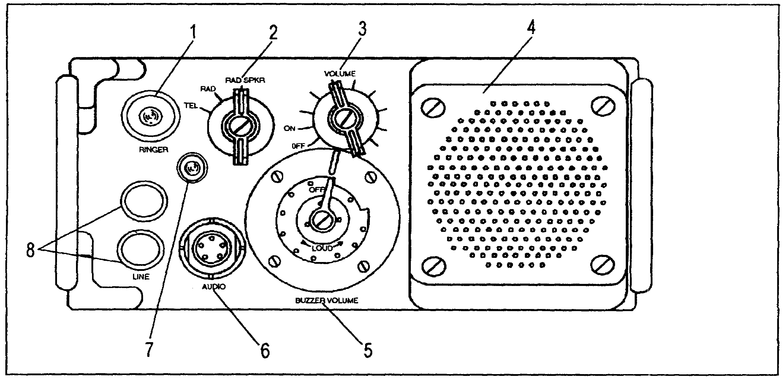

Figure 2-8. Remote control unit, AN/GRA-39

(1) The RINGER button (item 1) activates the buzzer and the call lamp in the local unit when pressed several times in rapid succession.

(2) The TEL-RAD-RAD/SPKR switch (item 2) is used to select the mode of operation of the remote control unit. Each position functions as follows:

- The TEL position permits voice communication with a local control unit operator.

AD 0448 2-14

- The RAD position permits a remote control unit operator to transmit or receive voice communications through the radio set when the TEL-REMOTE-RADIO switch on the local control unit is at REMOTE.

- The RAD/SPKR position is the same as the RAD position; it also provides speaker output when receiving.

(3) The ON-OFF switch and VOLUME control (item 3) turns the remote control unit power ON and OFF; it also adjusts the audio level of the handset or internal speaker.

(4) The internal speaker (item 4) permits monitoring of received radio signals with TEL-RAD-RAD/SPKR switch in the RAD/SPKR position.

(5) The BUZZER VOLUME control (item 5) adjusts the volume of the internal buzzer. It also provides an audible alarm when the RINGER button on the local control unit is depressed.

(6) The AUDIO connector (item 6) provides a connection point for the handset or other audio accessories.

(7) The call lamp (item 7) provides a visual signal when the RINGER button on the local control unit is pressed.

(8) The LINE binding posts (item 8) allow WD-1 field wire to be connected to the unit.

2-15 AD 0448

b. Local Control Unit Figure 2-9).

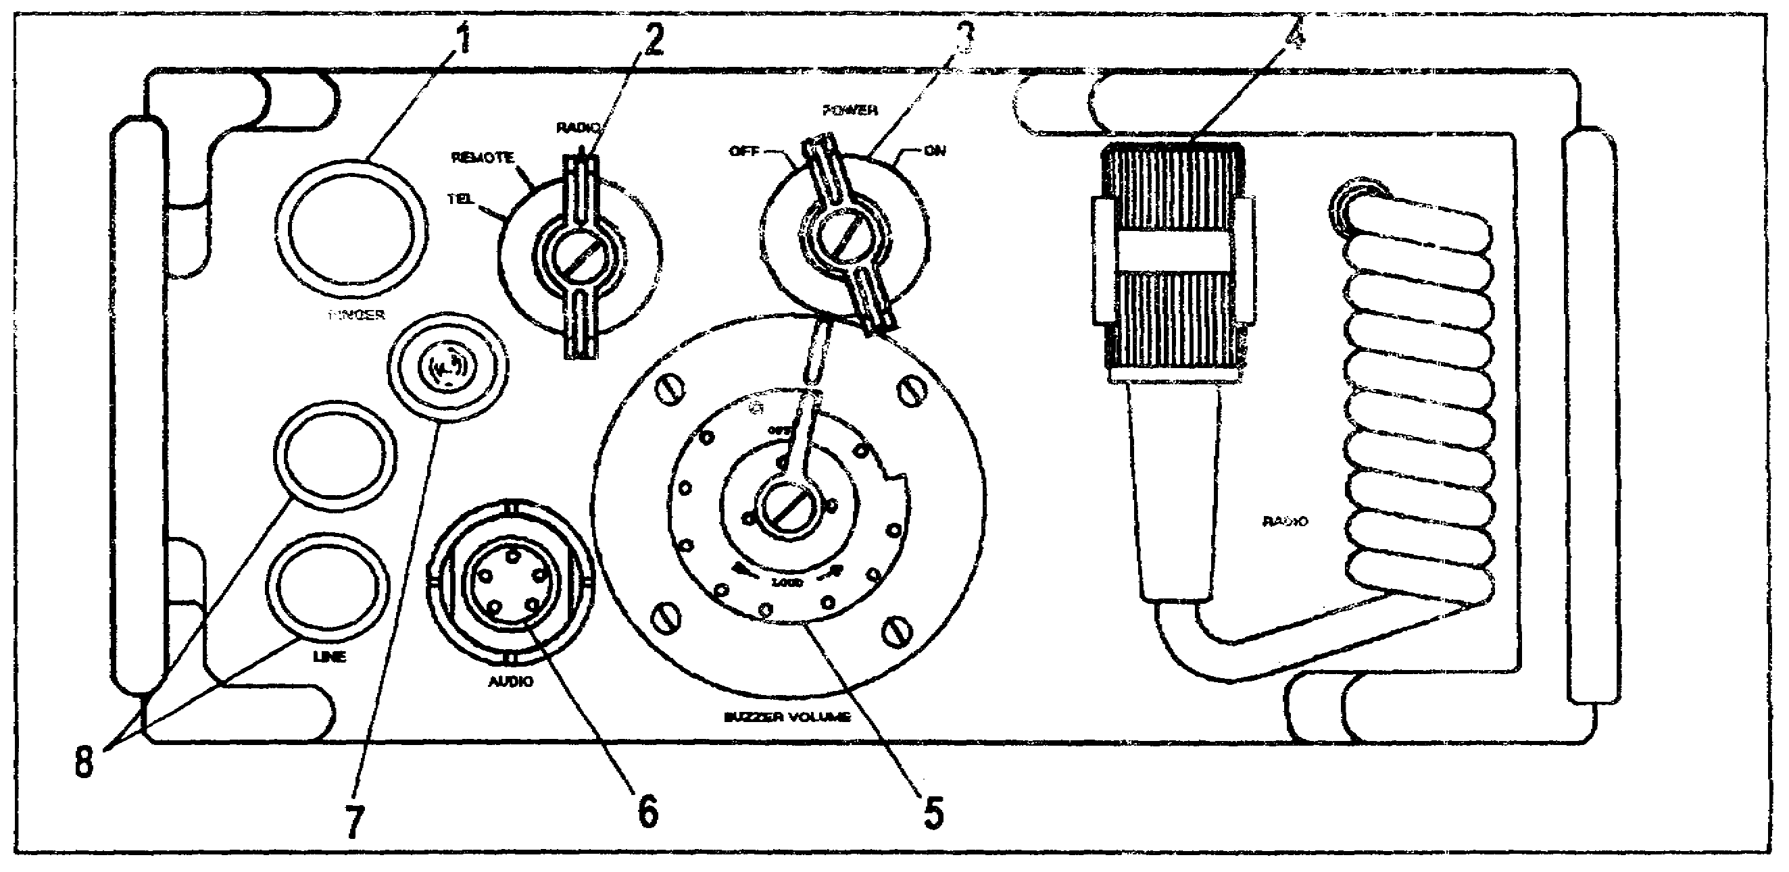

Figure 2-9. Local control unit, AN/GRA-39

(1) The RINGER button (item 1) activates the buzzer and the call lamp of the remote control unit when pressed several times in rapid succession.

(2) The TEL-REMOTE-RADIO switch (item 2) selects the mode of operation for the local control unit. It has three positions which function as follows:

- TEL position enables voice communications with the remote control unit. It also permits voice communications through a telephone switchboard. The switch is spring loaded in the TEL position and will automatically return to the REMOTE position when it is released.

- REMOTE position permits the remote operator to transmit and receive voice communications through the radio set.

AD 0448 2-16

- RADIO position permits the local control unit operator to transmit and receive voice communications through the radio set. The switch is spring loaded in the RADIO position and will automatically return to the REMOTE position when it is released.

(3) The POWER switch (item 3) controls power to the local control unit.

(4) The radio connector (item 4) is attached to a retractable cord. When it is connected to a radio set, it permits the local or remote control unit's operator to transmit or receive through the radio set.

(5) The BUZZER VOLUME control (item 5) is used to adjust the volume of the internal buzzer. It provides an audible alarm when the RINGER button on the remote control unit is pressed.

(6) The AUDIO connector (item 6) permits the attachment of a handset or other audio accessory.

(7) The call lamp (item 7) provides a visual signal when the RINGER button on the remote control unit is pressed.

(8) The LINE binding posts (item 8) provide for the connection of WD-1 field wire to the remote control unit.

2-17 AD 0448

3. INSTALLATION OF EQUIPMENT ON SITE (Figure 2-10). To operate a radio set with an AN/GRA-39 you need to connect it to the radio set. After the AN/GRA-39 is connected, you can operate the radio from the remote or local control unit.

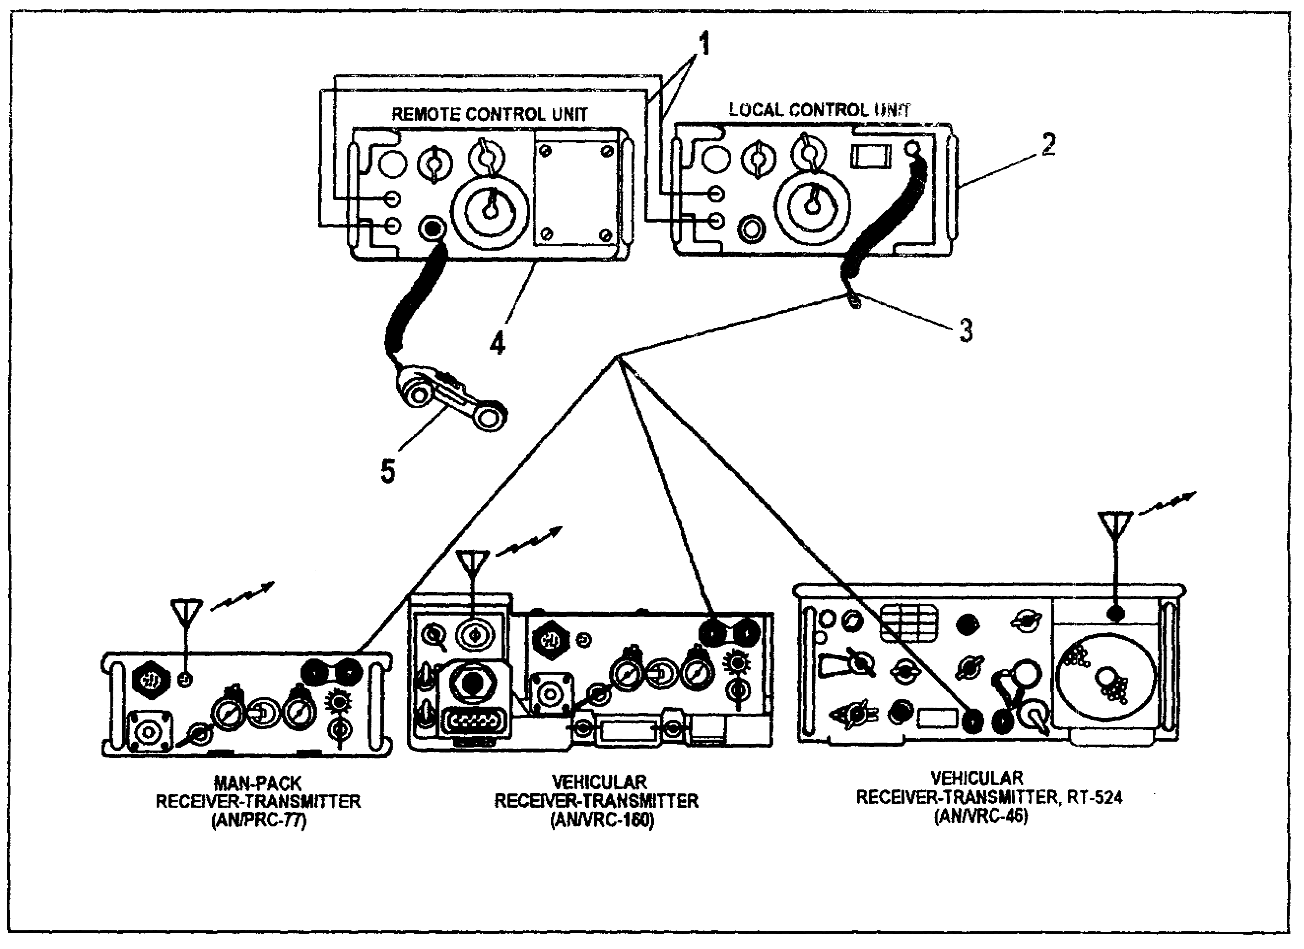

Figure 2-10. AN/GRA-39 installed

a. Locate the local control unit (item 2) next to the RT of the radio. Attach the radio connector (item 3) of the local control unit radio cable to the audio receptacle on the radio RT.

b. Locate the remote control unit (item 4) at the site from which it is to be used. Attach your handset (item 5) to the audio connector on the remote control unit.

AD 0448 2-18

c. Connect the line binding posts of the local control unit to the line binding posts of the remote control unit using WD-1 field wire (item 1).

4. SUMMARY. In this learning event, you learned that the AN/GRA-39 is made up from two units. You learned the purpose of both units and you learned the function of each units' controls, indicators, and connectors.

2-19 AD 0448

LESSON 2

PRACTICE EXERCISE

The following items will test your comprehension of the material covered in this lesson. There is only one correct answer for each item. When you complete the exercise, check your answers with the answer key that follows. If you answer any item incorrectly, study again that part of the lesson which contains the portion involved.

1. Which type of radio is the most widely used in a Patriot unit?

A. AN/VRC-46.
B. AN/VRC-47.
C. AN/PRC-77.
D. AN/GRC-160.

2. What is the power requirement of the AN/VRC-46?

A. Battery.
B. 22-28 VDC.
C. 110 VAC.
D. 22-28 VAC.

3. Which type of mounting plate is used for the AN/VRC-46 receiver-transmitter?

A. J-3513A.
B. MT-1898.
C. MT-4626.
D. MT-1029.

4. What is the nomenclature of the junction box installed on a MT-1029 for connecting it to a TSEC/KY-57?

A. J-3513A.
B. J-1898A.
C. MT-4626.
D. MT-1029.

AD 0448 2-20

5. You are using an AN/VRC-47 radio. How many antenna elements does the AB-15 use?

A. One.
B. Two.
C. Three.
D. Four.

6. What is the operating speed of the TSEC/KY-57?

A. 14,000 bits per second.
B. 15,000 bits per second.
C. 16,000 bits per second.
D. 17,000 bits per second.

7. Which receiver-transmitter is used with an AN/VRC-47?

A. RT-442.
B. RT-524.
C. RT-841.
D. RT-VRC.

8. What is the maximum range from which the AN/GRA-39 can operate another radio?

A. 1 mile.
B. 2 miles.
C. 3 miles.
D. 5 miles.

9. What happens when the ringer button on the AN/GRA-39 remote control unit is pressed several times in rapid succession?

A. The call lamp and the buzzer in the local control unit will activate.
B. The call lamp and the buzzer in the remote control unit will activate.
C. The switchboard call light will illuminate.
D. The TA-312 will ring.

2-21 AD 0448

LESSON 2
PRACTICE EXERCISE
ANSWER KEY AND FEEDBACK

Item Correct Answer and Feedback

1. A. AN/VRC-46.

Page 2-2, para 1.

2. B. 22-28 VDC.

Page 2-2, para 2a.

3. D. MT-1029.

Page 2-6, para 2f.

4. A. J-3513A.

Page 2-7, para 2f (2).

5. C. Three.

Page 2-9, para 2b (1).

6. C. 16,000 bits per second.

Page 2-5, para 2d.

7. B. RT-524.

Page 2-11, para 2e.

8. B. 2 miles.

Page 2-14, para 1.

9. A. The call lamp and buzzer in the local control unit will activate.

Page 2-16, para 2b (1).

2-23 AD 0448

LESSON 3

FM RADIO NETS

CRITICAL TASKS: 113-571-1020
113-571-1021

OVERVIEW

LESSON DESCRIPTION

In this lesson you will learn how to establish, enter, close and leave an FM radio net.

ENABLING LEARNING OBJECTIVES:

ACTION: You will identify and describe the procedures to:

1. Establish and close an FM secure radio net.

2. Enter and leave an FM radio net.

CONDITION: You will be given textual information and illustrations within the AD 0448 subcourse booklet.

STANDARD: To demonstrate competency of the instructions contained in this lesson, you must achieve a minimum score of 70% on the subcourse examination.

REFERENCES: The material contained in this lesson was derived from the following publications: FM 24-19, STP 44-16T1-SM, and STP 44-24T1-SM.

INTRODUCTION

The tactical effectiveness of communications equipment is no greater than the skill of the operators. By the same token, the most efficient communications within a net or command is attained when the operators habitually use the proper procedures in transmitting and receiving messages. This lesson was prepared to assist you when you communicate using an FM radio net.

3-1 AD 0448

LEARNING EVENT: ESTABLISH AND CLOSE A RADIO NET

1. GENERAL. Instructions pertaining to radio communications are contained in the signal operating instructions (SOI). The SOI provides for the organization of radio stations into nets, assigns call signs to the stations, designates net control stations (NCS), and assigns frequencies.

2. SPECIAL INSTRUCTIONS. Before you operate any radio set, obtain the equipment technical manual (TM) and carefully study the operating instructions. Refer to the panel diagrams, connection diagrams, and the paragraphs covering the description of components during the preliminary starting procedure. Make sure the cables are connected to the correct panel connectors and the controls are properly set. Even the most experienced operators should check their preliminary procedures against the TM references from time to time to ensure accuracy and avoid damage to the equipment.

3. ACTIONS IN OPERATING RADIO SETS. Radio sets issued to a unit vary in type according to the communications requirements of the unit. For example, some sets may be completely contained in one assembly, while others may consist of separate units that must be properly connected to assemble a complete radio set. The following procedures are required when operating a radio set.

a. Make sure that all the necessary components and accessories are on hand and ready for use. Refer to the equipment basic issue items listed in the TM. Never operate the transmitter without the antenna attached.

b. Look for knobs, dials, switches, and controls that are loose on their shafts, bind when being operated, will not operate, or are damaged in any way. Make corrections where possible or report the faulty condition. Make sure that all knobs and exterior parts are on the set. Immediately report any items that are missing.

c. Check that the plugs, connectors and connection receptacles are clean and in good condition.

AD 0448 3-2

d. Check the connector diagrams. The diagrams in the equipment TM show the type and number of cables required to interconnect the components of the radio set for each type of operation. The radio set may be damaged if the cables are connected to the wrong receptacles. If the connectors do not match, it is possible to physically damage the pins or sleeves of the connector. If a cable is connected to a receptacle into which it fits but does not belong, it may cause serious electrical damage to the equipment and injury to the operator.

e. Check the initial switch settings. Some radio sets can be seriously damaged if the switches, dials, and controls are not set to the required initial settings before applying power or making the initial tuning adjustments. Before applying power, check the equipment TM to be sure you have performed all the preliminary starting procedures. Be sure that radios installed in the vehicles are turned off before starting the vehicle engine. This will avoid damage to the radio equipment.

f. Start up the radio set. The equipment TM covers the proper procedure for starting the radio set. If there is a specific sequence for starting the set, it is described in the manual. Perform operations in the proper sequence.

g. Apply power after the proper connections are made and all switches are properly set.

h. Warm up the radio sets when first applying power in order to stabilize the equipment. In some cases, it is possible to damage a set by attempting to operate it without a warm up period.

i. Tune the transmitter to the desired frequency according to the SOI. Use the methods given in the TM to check for the correct tuning.

3-3 AD 0448

4. ESTABLISH A RADIO NET. For a radio net to function properly, there must be an NCS and at least one other substation. To establish a radio net the NCS must initiate the procedure and then substations respond accordingly. Follow the procedures outlined below when establishing a radio net.

a. The NCS will transmit a net wide radio call, as follows, which causes all substations to respond to the radio transmission:

"NET, THIS IS NCS, OVER."

b. The substations that use the radio net will now respond to the NCS's transmission. The responses are as follows:

"NCS, THIS IS 1ST SUB, OVER."
"NCS, THIS IS 2ND SUB, OVER."
"NCS, THIS IS 3RD SUB, OVER."

c. At this time, the radio net has been established. If the NCS does not have any radio messages to transmit, it will transmit the following statement:

"NET, THIS IS NCS, OUT."

NOTE: The radio net is now open, established, and under the control of the NCS.

5. CLOSE A RADIO NET. When the need for a radio net is no longer necessary, it must be closed. Do not simply turn off your radio set. The NCS must initiate the close down procedure. This procedure is as follows:

a. The NCS must make the following transmission in order to close a net:

"NET, THIS IS NCS CLOSE DOWN, OVER."

b. The substations that are member/users of the radio net now have the opportunity to respond. The responses are as follows:

"NCS, THIS IS 1ST SUB, ROGER OUT."
"NCS, THIS IS 2ND SUB, ROGER OUT."
"NCS, THIS IS 3RD SUB, ROGER OUT."

AD 0448 3-4

NOTE: The radio net is now closed and the operators may now power down their radio sets.

6. SUMMARY. In this learning event we covered how to establish and close a radio net. You also learned the initial actions you must take when starting up radio equipment.

3-5 AD 0448

LESSON 3
PRACTICE EXERCISE

The following items will test your comprehension of the material covered in this lesson. There is only one correct answer for each item. When you complete the exercise, check your answers with the answer key that follows. If you answer any item incorrectly, study again that part of the lesson which contains the portion involved.

1. What does the acronym SOI stand for in radio communications?

A. Signal operating instructions.
B. Standing operating instructions.
C. Signal operating information.
D. Safe operating instructions.

2. Which item should you never operate without the antenna attached?

A. Amplifier.
B. Matching unit.
C. Transmitter.
D. Speaker.

3. When should you apply power to the radio set?

A. After all the cables are connected.
B. After the proper connections are made, switches are set, and antenna disconnected.
C. After the NCS has instructed you to.
D. After the proper connections are made and the switches are properly set.

4. When the radio net is being established, what does the NCS transmit to the substations?

A. "NET, THIS IS NCS, OVER."
B. "NCS, THIS IS NET, OVER."
C. "NET, THIS IS NCS, OUT."
D. "NCS, THIS IS NET, OUT."

AD 0448 3-6

5. When the radio net is being closed, what does the NCS transmit to the substations?

A. "NET, THIS NCS, OUT."
B. "NET, CLOSE DOWN, OVER."
C. "NET, THIS IS NCS, CLOSE DOWN, OUT."
D. "NET, THIS IS NCS, CLOSE DOWN, OVER."

3-7 AD 0448

LESSON 3
PRACTICE EXERCISE
ANSWER KEY AND FEEDBACK

ITEM CORRECT ANSWER

1. A. Signal operating instructions.

Page 3-2, para 1.

2. C. Transmitter.

Page 3-2, para 3a.

3. D. After the proper connections are made, and the switches are properly set.

Page 3-3, para 3g.

4. A. "NET, THIS IS NCS, OVER."

Page 3-4, para 4a.

5. D. "NET, THIS IS NCS, CLOSE DOWN, OVER."

Page 3-4, para 5a.

3-9 AD 0448

LESSON 4

INSTALLATION OF A HOT LOOP

CRITICAL TASK: 113-588-1087

OVERVIEW

LESSON DESCRIPTION

In this lesson you will learn how to install a hot loop.

ENABLING LEARNING OBJECTIVES:

ACTION: You will describe the process that is used to install a hot loop.

CONDITION: You will be given textual information and illustrations within the AD 0448 subcourse booklet.

STANDARD: To demonstrate competency of the instructions contained in this lesson, you must achieve a minimum score of 70% on the subcourse examination.

REFERENCES: The material contained in this lesson was derived from the following publications: STP 44-16T1-SM, STP 44-24T1-SM, and TM 11-5805-201-12.

INTRODUCTION

When a unit is in a tactical environment, the need to communicate internally is critical to the timeliness and effectiveness of command and control. Inter-unit communications are accomplished using the TA-312/PT telephone. This telephone can be put into operation in several different configurations. This lesson will instruct you on hot loop communications using the TA-312/PT.

LEARNING EVENT 1: Describe the Telephone Set TA-312/PT

1. GENERAL. This learning event describes the installation and functions of the TA-312/PT.

2. PURPOSE AND USE. The TA-312/PT is a two-wire, battery-operated field telephone.

4-1 AD 0448

a. Technical Characteristics.

(1) Requires 3 volts of DC power to operate.

(2) Transmits audible signals in the frequency range of 300 to 3,000 Hz.

(3) Generates from 90 to 100 volts at a frequency of 20 Hz when the TA-312/PT is signaling another TA-312/PT.

(4) Obtains maximum range of 22 miles distance between two TA-312/PTs using WD-1 field wire.

b. Controls and Indicators (Figure 4-1).

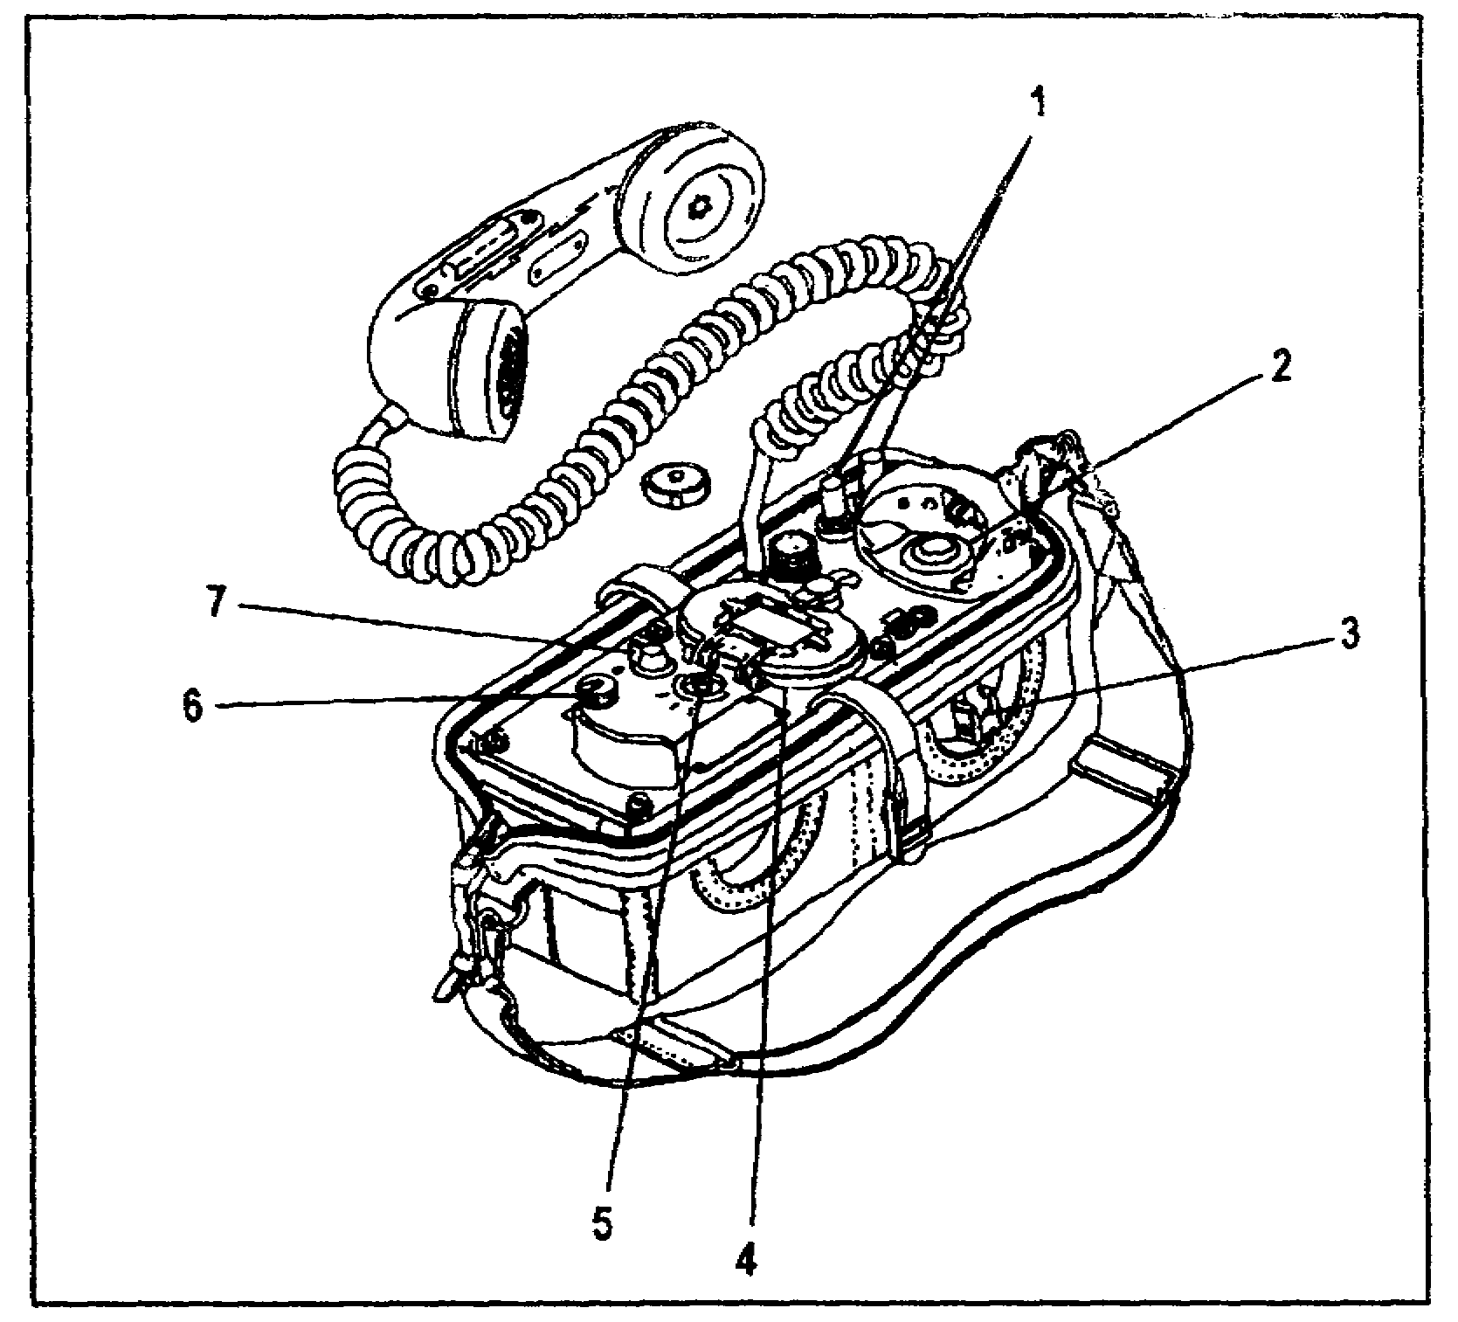

Figure 4-1. TA-312/PT with carrying case

(1) The binding posts (item 1) are used to connect the TA-312/PT to the WD-1 field wire.

(2) The hook switch (item 2) connects the handset to the field wire when the handset is removed from the cradle.

AD 0448 4-2

(3) The handcrank (item 3) generates 20 HZ/90-100 volts for signaling when turned.

(4) The battery compartment (item 4) provides for the use of two BA-30 batteries.

(5) The selector switch (item 5) connects the internal circuits of the TA-312/PT to the power source being used. For a hot loop operation, this switch must be in the LB position.

(6) The buzzer volume control (item 6) is used to adjust the volume of the TA-312/PT ringer.

(7) The EXT-INT switch (item 7) is used to place the handset in the INT (internal) position. The EXT (external) position is not used for hot loop operation.

3. SUMMARY. This learning event provided you with instructions on the purpose and use of the controls and indicators and a description of the TA-312/PT with its technical characteristics.

LEARNING EVENT 2: Install a Hot Loop

1. GENERAL. When two or more TA-312/PT telephones are on the same WD-1 field wire circuit, and the field wire returns back to the first telephone in a closed circle, the circuit is known as a hot loop. A generic hot loop with four TA-312 telephones is illustrated in Figure 4-2.

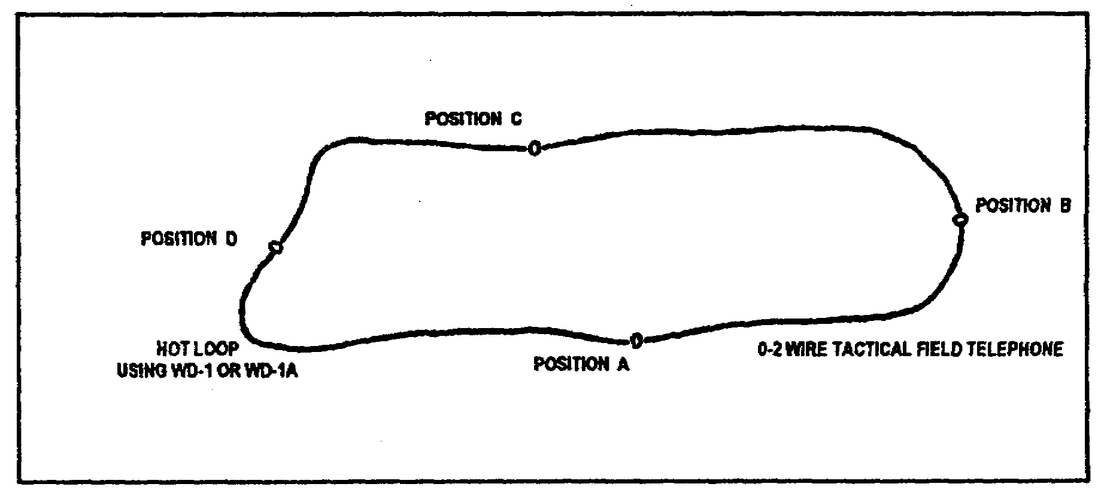

Figure 4-2. Hot loop with four TA-312/PT telephones

4-3 AD 0448

2. SPECIAL INSTRUCTIONS.

a. To install a TA-312/PT in the hot loop at your assigned position, simply strip the insulation off the WD-1 field wire and insert the bare wires into the binding posts (Figure 4-3) of your TA-312/PT.

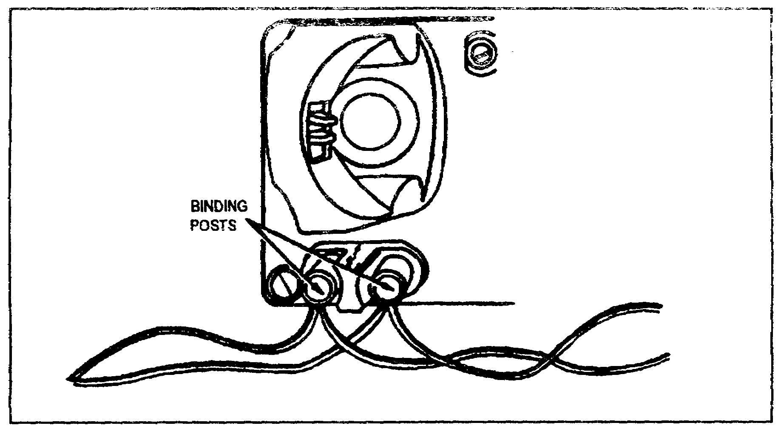

Figure 4-3. WD-1 and TA-312/PT connections

b. The amount of WD-1 wire to strip is shown in Figure 4-4. Separate the two leads of WD-1 wire about 8 inches and bare the wire as shown, about ½ inch.

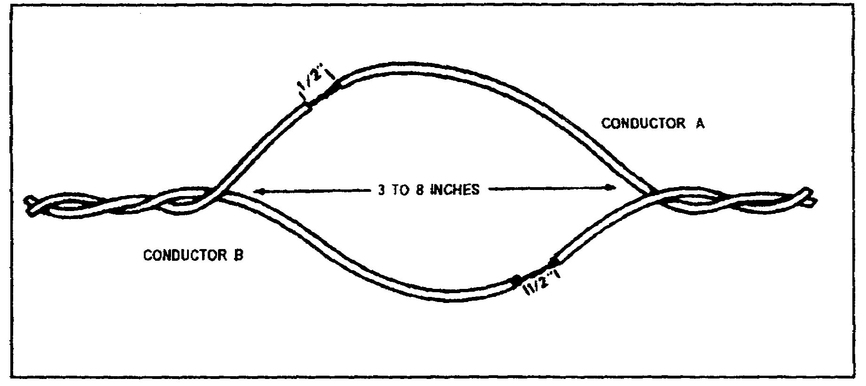

Figure 4-4. WD-1 preparation

3. SUMMARY. This learning event provided you with instructions on how to install a hot loop, connect the TA-312/PT telephone to a hot loop, and prepare WD-1 field wire for a hot loop.

AD 0448 4-4

LESSON 4

PRACTICE EXERCISE

The following items will test your comprehension of the material covered in this lesson. There is only one correct answer for each item. When you complete the exercise, check your answers with the answer key that follows. If you answer any item incorrectly, study again that part of the lesson which contains the portion involved.

1. What is a TA-312/PT?

A. A radio.
B. A field telephone.
C. A truck.
D. A transmitter.

2. What are power requirements for the TA-312/PT?

A. 208 VAC.
B. 110 VAC.
C. 24 VDC.
D. 3 VDC.

3. What is the frequency range of available signals that the TA-312/PT can transmit?

A. 3 to 300 Hz.
B. 300 to 3000 Mhz.
C. 300 to 3000 Hz.
D. 300 to 3000 Khz.

4. What is the maximum range of the TA-312/PT using WD-1 field wire?

A. 2 miles.
B. 10 miles.
C. 22 miles.
D. 50 miles.

4-5 AD 0448

5. What is the function of the hook switch on the TA-312/PT?

A. Disconnects power from the handset when it is removed from the cradle.
B. Connects the handset to the field wire when the handset is removed from the cradle.
C. Connects the cradle to the battery power.
D. Connects the handset to the selector switch.

6. How many batteries does the TA-312/PT battery component hold?

A. One.
B. Two.
C. Three.
D. Four.

7. How much insulation should you strip from the WD-1 when connecting a TA-312/PT to a hot loop?

A. 1/4 inch.
B. 3/8 inch.
C. 1/2 inch.
D. 7/8 inch.

4-7 AD 0448

LESSON 4
PRACTICE EXERCISE
ANSWER KEY AND FEEDBACK

Item Correct Answer and Feedback

1. B. A field telephone.

Page 4-1, para 2.

2. D. 3 VDC.

Page 4-2, para 2a (1).

3. C. 300 to 3000 Hz.

Page 4-2, para 2a (2).

4. C. 22 miles.

Page 4-2, para 2a (4).

5. B. Connects the handset to the field wire when the handset is removed from the cradle.

Page 4-2, para 2b (2).

6. B. Two.

Page 4-3, para 2b (4).

7. C. 1/2 inch.

Page 4-4, para 2b, Figure 4-4.

4-9 AD 0448

